Role of ICT in Rural Development: An Experience From Indonesia

Onno W. Purbo, Ph.D
Ashoka Senior Fellow
Eisenhower Fellow

Abstract

Role of ICT in rural development in Indonesia will be described. It will focused on two (2) main ICT technologies, namely, community radio and Internet. Due to limitation in electrical power, people's level of education, economic scale, not all Indonesian rural areas is suitable for advanced ICT technology and, thus, simpler / appropriate ICT should be adopted.

Experiences in bottom up community based approaches through self-finance empowerment and technical knowledge spreading will be described. In an unfriendly regulatory environment commonly found in developing countries, such as, Indonesia, a community-based distributed infrastructure may survive the evolution processes easily rather than rely on a centralized commercial services commonly found in the west. The approach is very much bias on the Author’s 12+ years experience in deploying a movement of community based WiFi infrastructure in Indonesia. It results in an alternate strategy to deploy ICT infrastructure that rely heavily on community ability to provide such service suited for developing countries.

Community education and empowerment processes would be the key in the whole process. It takes 12+ years through books, articles, newspaper, magazine, seminars, demo, workshop and roadshows to convince a lot a people, all done without financial support from the government. Ability to connect schools to the Internet funded by the communities would be the key of success.

Today, we witness about 600 dedicated community broadcasting radios out of 1000-2000 community radios. Many of these radios are in remote Indonesia. Futhermore, we witness 20-25.000 Wireless Internet nodes with an increasing 2000-3000 new Wireless Internet nodes per month. Many of these nodes are now spreading towards remote Indonesia. Starting the beginning of 2006, a community based Internete Telephony VoIP Rakyat at http://www.voiprakyat.or.id is the dawn of Indonesian People's Telco. In 2007, more than 60.000 VoIP Rakyat subscriber is registered.

Facts and Figure of Indonesia

Some of the formal facts that are download-able from the Indonesian statistical bureau at http://www.bps.go.id. A glimpse of these formal facts are:

- About 100+ million Indonesians are living without proper electricity.
- About 105.8 million Indonesian of the age of 15+ years are in the work force. More than 95 million are working, the rest are still looking for work.
- On average, Indonesian stays about 7.4 years in school. On average, about 91% can read.
- About 56% of Indonesian population received a maximum of primary school education out of which 9% never received any education.

Some of the facts in ICT sector are:

- 64Kbps 24 hour Internet connection via Telco infrastructure would cost US$400 / month.
- After 10+ years of struggle, WiFi 2.4GHz band is unlicensed in January 2005.
- WiFi band 5.8GHz is still licensed, taxed at approximately US$2200/year/node.
- In 1993, there were not many ICT books in local Indonesian language.
- In 1993, there were few Indonesian Internet users.

Some encouraging facts:

- As of 2007, there are 15+ million Indonesians on the Internet.
- There are a total of 215.200+ schools all over the country in which 46.5+ million students are studied. At high school and university level, we are looking at 17.5 million students in 45.800+ high school & universities.

Deploying a community-based ICT infrastructure in an unfriendly environment is an art. It is nearly impossible to initially run a professional and commercial based ICT infrastructure as known in developed countries. Low cost community based approach through community empowerment may provide self-finance ICT infrastructure in Indonesian remote areas.

An Alternative Strategy for A Self-Finance Community Based Approach

Basically, the strategy used in the last 12+ years of struggle is a creating a movement within the communities to build community based infrastructure invested by community own funding. Through self-finance capacity building and community empowerment is the community based ICT development. It is an art in itself to be able to create a countrywide community based self-finance self-motivated ICT movement with minimal support from the government and no loan from World Bank & IMF. Such movement can only be created as community believe in its benefit. It is an art to build such believe within the community.

Stereotyping Poor and Remote Communities.
If I may stereotyping poor communities, I will likely to divide the communities into two (2) major categories, i.e.,
Those who would speak and listen only. These are most likely be the older generation / uneducated / primary school dropped out. They will likely more resistance to change especially the one introduced by aliens.

Those who are having some enthusiast on new things / new technologies. They might be a younger generation & have some sort of education above primary school level.

The younger generation may easily adapt the new ICT technology. However, to reach larger audience within the communities voice communication mode should be implemented as well.

Proposed Basic Strategic Approach
The basic strategy is to encourage the individual within the community to become a knowledge producer and sharing the knowledge to their community or surrounding other communities. Knowledge must not be in written form. It may be in audio form to reach larger audience in poor communities specially the older generation.

Educated, dedicated & sometimes militants are the key to success, behind all the movement and activities in deploying such revolutionary infrastructure. This attempts to transform Indonesia into knowledge-based society clearly shows the strength of community education.

In this section, practical strategies in initiating such community based ICT movement will be explored. There are several important ingredients that enable such a movement, including,

- Clear cause must exist. Some may see this as the vision; others may see it as the stumbling block, or challenge.
- There must be a good informal leader that has the vision, knows the way, shows the way and goes the way. Finding such leader is an art and normally quite difficult.
- Ability to shift the paradigm of the common people, from being a information / knowledge consumer into an information / knowledge producer.

In closely examine the technology trends; one may easily notice that technology is becoming more affordable and more user-friendly. Thus, the future challenge in the existing regulatory framework is apparent as shown in the table below.

 | Conventional | Future?
Technology | Expensive & Complex | Affordable & User-friendly
Specialized Skill | Yes | No
From | Licensed by Government | Common People
Invest by | Investor (Multinational) | Common People
Build by | Vendor & Contractor | Common People
Run by | Operator | Common People
For | User & Customer | Common People

It is not surprising to see a significant shift in the industry towards ICT-based infrastructure invested by people, built by people, and run by people for the people.

This philosophy enables communities, offices, resellers as well as remote communities to act as unlicensed service providers and / or unlicensed physical network operators. Such shift creates a significant problem in the policy & regulatory framework that accept only licensed operators to run a network. Thus, there is basically no available room for a community-based infrastructure; with homebrew equipments, from people, by people, for people. There is no room for community based ICT infrastructure, such as, WiFi-based last mile nor for VoIP based community networks.

Thus, the reasons & challenges are very clear.

However, having access to low cost technology on hand is not enough. ICT knowledge in local language is fairly limited; translating the knowledge on the Internet or various technical books is very labor and funding intensive.

Therefore, the ability to generate and distribute ICT knowledge in the local language at a low cost will be critical. Note that the local languages in remote Indonesia might be different from the national language. Thus, double translation processes might be required for remote communities.

Sustaining the deployment for the digital divide bridge in a long period of time and the ability to self-finance local knowledge generation cycle are the two (2) crucial factors. Key success in deploying the information infrastructure would rely heavily on the masses of quality & skill of the human resources. The ability to distribute the required knowledge & skills at a low cost would be crucial in creating demand & needed technicians, skilled at deploying the infrastructure. The ability to access ICT knowledge in English would be an added benefit. Interestingly, since equipment can be shared and is getting cheaper, funding is not the primary concern in deploying ICT infrastructure.

In creating a self-financed knowledge cycle, there are basically two (2) critical strategies, namely,

- Transforming some locals into local knowledge producer.
- Supply created-by-demand strategy.

Unfortunately, the whole process may take more than ten (10) years. Never ever expect to financial benefit in a short time, it will never happen that way.

Most failures are likely due to demand created by the supply path or heavy top-down approaches. Failure to increase society's level of education will likely impede the development of information infrastructure.

A conservative route would be initially to connect the school and university network. School network will affordably cost US$ 0.50/student/month with a Return of Investment in 1-2 years. Furthermore, the young generation will be an effective agent of change for their parents and surrounding communities.

In developing countries, like Indonesia, practical know how on various ICT technologies in local language is in high demand. Publishers are begging for manuscripts on various ICT practical guides in local language. Most of the best Authors are in their 30’s and acquiring their ICT knowledge through their school and university’s Internet access. Thus, it is very crucial to integrate schools and universities to the Internet, as they are the one who produce the desperately needed local knowledge 3-5 years after their initial introduction to the Internet.

Simplified Steps in Self-Finance Knowledge Generation & Demand Creation

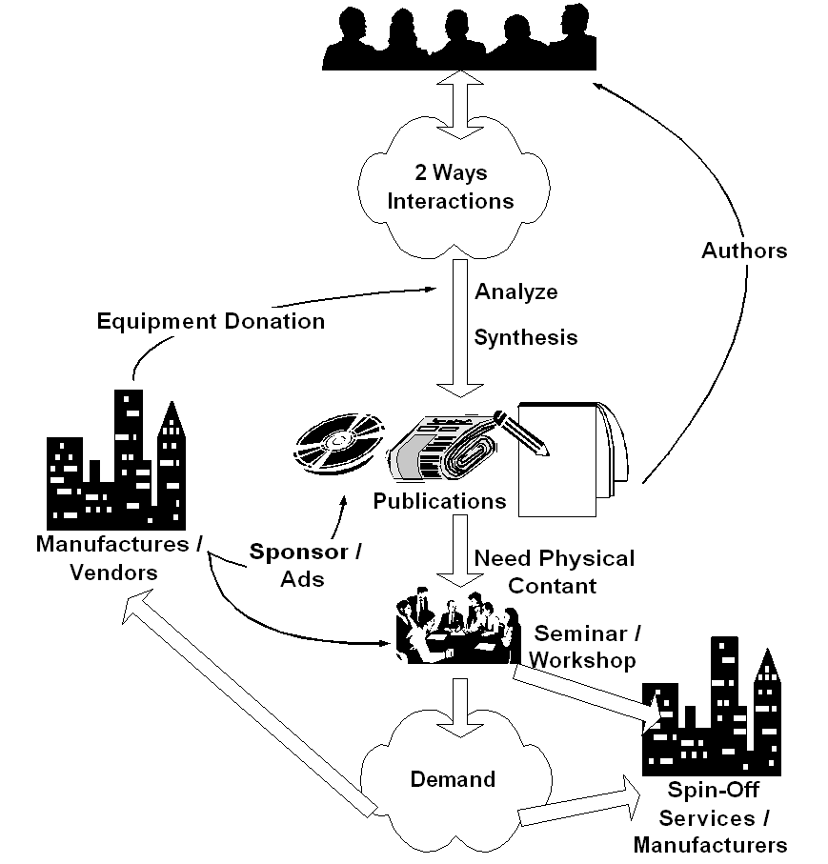
It all start from discussion platforms of which community member may have two ways interaction. Such platform is basically to facilitate tacit (implicit) knowledge exchange. It may be community radio or TV talk shows, or Internet mailing lists at no cost. Free mailing list service at yahoogroups.com (http://groups.yahoo.com) has been very successful in facilitating this process for Indonesians. Unlike most assumed condition by 1st world countries, no abundant local content is necessary to start with. Community may create their own content through platform that exploits community implicit knowledge exchange. Existence of informal community leaders is crucial in such platform, a leader not necessary the moderator.

It may take 1-2 years, before some individuals start analyze and synthesis the collective community knowledge. These individuals, mostly young, should make their knowledge implicit in written form. It should be distributed through conventional channels, such as, newspaper, magazine, radio & television, and, thus, transform the mindset of others who are not yet using ICT. It costs US$ 1-2 to access the knowledge in books or magazines. The young authors, in return, normally receive an incentive of US$ 15-25 /article or US$ 400-700 /book. The best selling and the most productive Authors, it would be easy to get equipment donation from various vendors.

In many cases, some people may need physical contact through seminar and workshop to be convinced. We are normally looking at 500-1000 participants/seminar. The favorite seminar agenda would be to provide tutorial and demonstration on various ICT technologies. It costs US$ 3 /person to enter such seminars as many vendors may likely give sponsorship. Marketing through local newspaper or computer magazine is crucial in getting such large participants. A hands-on workshop with two (2) persons on one computer will be more costly about US$ 40-50 for 1-2 days workshop, and normally accommodate 30-50 participants.

As more people convinced, demand is created within the communities for their very own "digital divide bridge". Sound business plan, with US$ 2000-4000 investment and return in 1-2 years, will persuade people to invest their money to deploy their very own "digital divide bridge". A 50 cents/student/month in a school network or US$15-30/house/month with Return of Investment within 1-2 years is a good enough incentive for people to invest their own money into the "digital divide bridge". Success stories & word of mouth is the typical process to spread the words. Manufacturers and business communities will gladly responds to such opportunities. Some individual would spin-off and create their service companies to meet the demand. A conservative path would connect the school network first before connecting the neighborhood.

Deploy & maintain the "digital divide bridge" may be done at 50 cents/student/month at school or about US$ 15-30/month/house. Ah, we finally have financially sustainable digital divide bridges with minimal support from the Bank, the government & hopefully license free.

In the end, as more and more people connected to the Internet, pressure will be high for the regulators to work on their policies. Hoping no distortion made during the process.

As shown clearly, all the sequences are self-finance. The normal (not the ideal) sequence would be awareness, demand, business response, and regulation. These steps would not be completed over night. It will take years to complete these steps. Committed leaders & personals are needed for such long-term deployment ICT movement beyond normal government bureaucracy & cycles.

In rural and remote areas where talk-and-listen is the primary communication means, computer & Internet based ICT may not work well. Community radio and television might be the best alternative. One can easily build a community radio transmitter for under US$100, and, thus, enables its surrounding community to speak up and creates an information-diversity environment. A network of community radio would be a strong barrier against information domination by national / multinational broadcasters. After years of struggle, the Indonesian community broadcasters may now use 107.6MHz, 107.7MHz and 107.9MHz for community broadcasting purposes.

In a more advanced ICT Society, we rely heavily to the Internet Infrastructure. Most Indonesian Internet activists, such as, I Made Wiryana (Germany), Michael Sunggiardi (Bogor), Adi Nugroho (Makassar), Irwin Day (Makassar), Ismail Fahmi (Bandung), Rahmat Samik Ibrahim (Jakarta) etc. would prefer to publish their work freely on the Internet. You may find their work in Indonesian Digital Knowledge Foundation (IDKF) http://www.bogor.net/idkf, Pandu Team Website http://www.pandu.org, http://www.ilmukomputer.com, and http://bebas.vlsm.org. It contains thousand articles and references on various ICT aspects in Indonesian language.

Copyleft & copywrong movement provides free literature and education and really helps the building of Indonesian Internet society. Many Indonesian new dotcommers may mirroring these sites, thus, enable rapid distribution of the knowledge to the society.

One may be surprised by the amount of funding & sponsorship received by putting the copylefted knowledge in public domain. Depending on the coverage of the audience / readers, it may surpass the salary of professional executive with fixed job and fixed income in Jakarta the capital city of Indonesia.

Electrical Power in Rural

There are several suitable prerequisites must be met prior to implementation of ICT in rural development especially the availability of electricity in rural and remote areas. A community based electrical power supply initiative has been driven for sometimes by Tri Mumpuni and her group at IBEKA http://ibeka.port5.com.

IBEKA developed are two electricity systems being developed: one is called isolated scheme and the other is connect to grid scheme. Both have advantages to improve the livelihoods of the poor community in rural area. What makes difference this works to normal rural electrification program, this activity is called community based and using renewable energy source. Because most of the community in developing countries are poor and uneducated, so community based electrical supply has to be introduced by giving social preparation whenever the project started and giving equity building, not just capacity building to the community. Equity building is giving the community right to manage their assets and giving ownership to the community of their own resources.

Development in general is just physical construction, there is no community involvement, and if the community is invited to be involved, usually it is only lip service, in the surface, formality only. But community based is giving the right of the community to be involved from the very beginning of the project until it’s commissioned.

Isolated Grid Scheme : Electrifying the community with appropriate technology (micro hydro) using isolated grid scheme. The communities together with IBEKA build the facilities and operate and maintain by the community themselves. The social preparation is the main key success to make the facilities sustainable. During the social preparation we will have the baseline data information such as the number of beneficiaries (usually ranging from 50 houses to 1500 houses). The income and expenditure pattern (this is to help making the decision about how much is the electricity tariff should be decided). The village economic potential (this will help us to enhance the community economic activities in order to increase the income of the family). Forming cooperative or any organization that will run the power plant including choosing the operator. Picking the operator who will be the responsible person to operate and maintain of the power plant system. And the operator will receive training and he or she will be involved in the beginning of the power plant system construction, including coming to the workshop to learn how turbine and control is manufactured.

After having the electricity, the community can use it for other development purposes than just lighting the house at night such as for agriculture product processing, rice mills, sewing machines, saw mill, etc. Sometimes it is for vaccine storage in the village clinic. Source of fund for this development: Grant, and partly grant partly community contribution.

Connect to grid Scheme: Developing the power plant together with the community in the area where the national grid line has already existed in the village and some of the community has already become a national utility consumer. The electricity resulted from the power plant sold to the national grid. And the money from the grid is used for village development purposes. In one village the money usage based on the community consensus, and based on the village meeting. Some villages agree to use the money for school children scholarship, health care, income generating activities, village infrastructure development, village operational, etc. In another power plant location, the money from electricity sales is used for funding the whole activities of one school, the teacher as well as the students and other overhead cost. Meaning that the school if free of everything for the students. If there many power plant like this scheme can be developed, there will be many villages have routine income monthly, and this is very useful to fund the community economic activities. As we learn many villages usually need fund from outside contribution to start their economic activities.

Funding sources for this activity: Coming from donor as fully grant, partnering between the communities and the local private or outside investor who give the community share in their activities. The investors calculate the resources as community share.

Community Radio

In the year 2002, the Indonesian government released the act/regulation no 32 year 2002 for broadcasting. In the 2002 act, communities radio has included and allow to operate in the Republic. Although, in reality, some repressive actions are still existed in some areas.

Typical FM community radio broadcast is using a maximum output power of 100 Watt ERP at maximum antenna height of 30 meter. Frequency is generated using stable phase locked loop (PLL) operated at frequency 107.6-107.9MHz with maximum bandwidth of 350KHz. Typical maximum coverage area is about 36km square. Typical content are general information, education and entertainment.

Community radio is much more easier to implement as it cost approx. US$100 or less for the bare bone system. It is not surprising to see communities build their own FM radio transmitter. Many collectively fund their radio. Some sell their cattle, such as, goat, to self-finance the transmitter.

Vocational schools have been part of the movement to initiate community radios in communities. Since no skill & prerequisite level of education to become a radio listener, community radio sprung quite nicely in rural Indonesia.

Coalition of community radio networks has been formed in many areas in Indonesia, some of these networks will be covered. One of the good promoter of community radio network is 68H Radio News Agency http://www.krb68h.com that covers 429 radio all over Indonesia with an average of 14 radio in each province.

Many of these radios collaborate in radio network, such as, Farmer's Voice Network (Jaringan Radio Suara Petani, JRSP), Fisherman Voice Network (Jaringan Radio Suara Nelayan, JRSN), the Indonesian Community Radio Network (Jaringan Radio Komunitas Indonesia, JRKI) in Jawa Barat and Yogyakarta, and Labour Voice Network (Jaringan Radio Suara Buruh). Tosca Santoso one of the director of 68H Radio News agency noted that there may be only approximately 600 healthy / committed community radio in Indonesia.

The Farmer's Voice Network (JSRP) started in 1999 mostly located in west java island region. Farmer's Voice Network have a member of more than 600 community radios in their network. An example of a member of Farmer's Voice Network is Radio Citra Utami FM located in Cianjur, West Java.

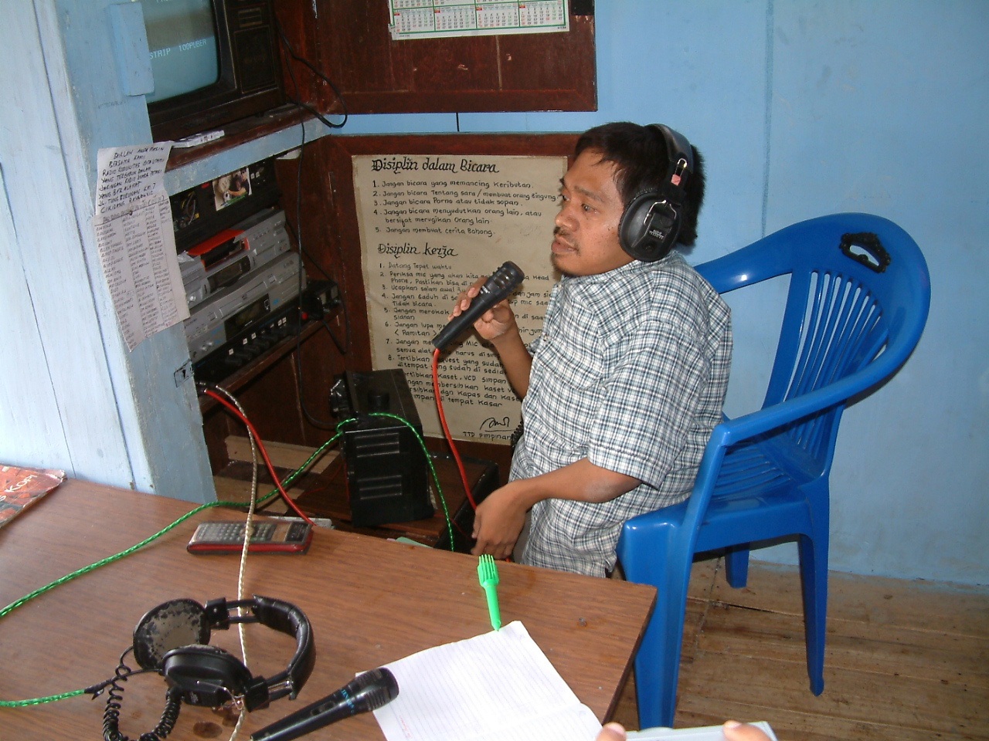
Radio Citra Utami FM lead by by Mr Dadang. he was injured and has no formal education. The radio transmitter is build by Mr. Dadang himself. The main listeners are farmers in the surrounding area. Information and knowledge sharing in the surrounding community has becoming a common phenomenon in these community radios.

A good example of information and knowledge sharing was told by Silverius Oscar Unggul, the director of TELAPAK.ORG, one of the commissioner of community radio and community television in Kendari city in Sulawesi Island. In Oscar's community TV & radio station, locals are queuing to share their information, knowledge and expertise to others. One may share their expertise in cooking. Others may share expertise in farming. Since all are local people, it is a great incentives for the local to hear or watch the local community stations as compared to the national broadcasting station that may not carry their program of interest.

Interestingly, such approach increases the rating of the particular local community broadcasting station that very much in favor of advertising agency that look for large local community coverage. In the end, these community broadcasting stations will financially survive and may continually serve the local communities. Oscar mentioned that effort is currently underway to replicate such approach to other community radio & community television to sustain the community radio and enable a local community based electronic media program.

Wireless Internet in Rural Indonesia

As computer technology emerges and becoming cheaper and powerful strong pressure to move Indonesia, including rural Indonesia into the Internet, quite apparent. However, unlike community radio, computers require a much demanding prerequisites, such as, literate / educated users, willingness to invest on computers / IT equipments, demand for written information, sufficient electrical power.

The current rural computer based coverage is more limited, especially to the vicinity of urban and remote areas. Although, more than 50% Indonesian districts are now connected to the Internet.

From technology point of view, major technology used to interconnect the rural Indonesia are WiFi & Open Source Linux based systems. Some of these technology is well documented on the Web, such as, http://sandbox.bellanet.org/~onno/ and http://wndw.net.

WiFi equipment is originally designed for indoor usage. However, in our community-based network, it is also used outdoors. Unlike indoor installations, there is an outdoor external antenna used along with a 20-30 meter tower to extend the range of coverage to reach 5-8 km distances.

Basically, user-friendly & low cost (mostly Taiwanese) indoor WiFi equipments are modified to be used in outdoor environment as community based fixed wireless broadband 11-22Mbps last mile infrastructures. The broadband WiFi access is then shared through a simple & PC based proxy server to its surrounding neighborhood. The whole operating cost is shared among the neighborhoods connected through a UTP LAN cables or outdoor WiFi access.

In Indonesia, today, outdoor WiFi end user equipment can be obtained at US$35. Some may use UTP LAN cable to connect their neighborhood, which may cost around US$50 per house. The operating cost per household to have 24 hours Internet access is at an affordable US$10-30 per month. The whole investment and operation of the infrastructure is mostly done by the communities and return within one to two years time.

Unlike most western & developed countries that have a luxury to access the Internet through high speed DSL services, such luxury is rare in many part of Indonesia. Thus, the best solution for Indonesian is to use wireless broadband specially WiFi based equipment that can be obtained at fairly cheap at around US$15-25 for USB WiFi dongle.

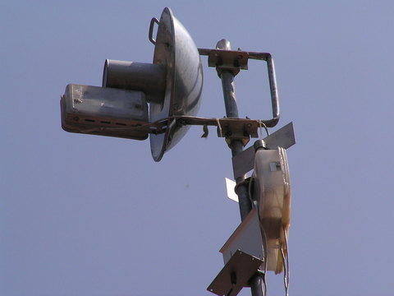
In early 2006, Wokbolic technology was introduced by Mr. Gun that also known to the community as e-goen. Mr. Gun lives in Purwakarta city a small town about one (1) hour drive east of Jakarta. Mr. Gun was graduated from a vocational school in Jogjakarta and now seem to serve as an engineer at Indosat's main satellite ground station in Jatiluhur city, fairly close to Purwakarta.

Mr. Gun is very active at indowli@yahoogroups.com, the main mailing list of the Indonesia Wireless Internet community to share his knowledge and quite often organizing workshop on Wokbolic technology.

E-goen's Wokbolic technology can be seen at http://pg.photos.yahoo.com/ph/gunpwk/my_photos. It consists of USB WiFi dongle (about US$15-25), a Wok (about US$5), a used tincan or PVC pipe. The total cost of the equipment is only about US$35, much less then a GSM handphone. Such simple equipment plays an important role in connecting the communities within 3-5 km ranges. It enables many communities to be connected at local speed of 11Mbps while keeping the cost of the subscriber equipment down to about US$35.

There are many types of e-goen Antennas. To give the feel of the antenna, some of them are called,

- Used Door Antenna
- Khong Guan Antenna
- Sliced of A Can Antenna
- Pan Lid Antenna
- Sectoral Antenna
- Panbolic
- Wokbolic

The WiFi based communities can be found on the Internet mailing list such as indowli@yahoogroups.com and indowli@groups.or.id with approximately 10.000 active members. Since US$35 is much lower cost that a hand phone and is quite affordable for most people, the installation rate of such WiFi equipments is quite rapid about 2000-3000 new nodes every months.

Community Neighborhood Network

Deploying a community-based infrastructure in an unfriendly environment is an art. It is impossible to initially run a professional and commercial based fixed wireless broadband services as known in developed countries.

We need to adopt a guerrilla strategy to deploy low cost broadband infrastructure. The infrastructure must be distributed, autonomous, self-finance and not centralized. Cost, afford ability and easiness would be key in deploying a self-finance community based fixed wireless broadband infrastructure.

The Community Neighborhood Network model moves away from the conventional Telecentre model, which centralizes all connectivity in a single room. The new WiFi Community Network distributes connectivity throughout the neighborhood thereby reducing monthly costs for 24 hour Internet access. As more houses or computers in the neighborhood become connected to the neighborhood network, the operating cost as well as the initial investment cost will be declined.

To get a better idea of the savings one can achieve by developing an outdoor WiFi neighborhood network, let us conduct a price comparison. Broadband 24-hour Internet access from the Indonesian Telco costs US$400-800/month/user. This price allows the user to exchange limited traffic over the network with a high level QoS (Quality of Service). In comparison, WiFi Neighborhood Network broadband 24 hour Internet access costs US$15-45/month /neighbor. This low price includes the ability for users to exchange unlimited traffic on the network with variable QoS, depending on the level of traffic at that time.

Currently, there are close to 15.000 institutions including broadband Internet cafes, schools, and residential neighborhoods are using WiFi technologies as an alternative to conventional connectivity options.

Having a large mass of outdoor fixed wireless broadband users and very much distributed in nature, not centralized under a single entity / service companies. It would be very much difficult for the regulator to stop such self-finance large movement.

Regional Networks

Now that we know how to link individual communities, we can take a step back to look at how to connect the communities to one another through a broader regional network. The two (2) most common technologies to build the regional network are satellite and fiber optics.

DVB-RCS satellite backbone is the cheapest solution currently available to Indonesia is selling for US$200-700 at 64Kbps, depending on the agreement on the satellite ground station. Fiber optics/microwave backbone can be rented from cellular operators, such as, XL. The excess capacity in cellular operator is used to for our data traffic between cities. The local ISP (Internet Service Provider) normally rents the backbone from the cellular operators, and then resells it to the community.

Internet Telephony in Indonesia

Another trend seem to emerge in 2005, as many communities are now having "broadband" 24 hours Internet access, Telephony over Internet seems to be more feasible. From regulatory point of view, no license is necessary for Internet Telephony as long as it is used for private network, not commercial and not connected to the incumbent networks.

A brave example of it is the VoIP Rakyat or People's VoIP at http://www.voiprakyat.or.id. It is initiated by Anton Raharja (anton@ngoprek.org) from the ICT Center Jakarta. VoIP Rakyat technology is a Session Initiation Protocol (SIP) based Internet Telephony softswitch that allow people to get SIP phone number for free and able to call free over the Internet. Interconnection to local PBX is commonly done. In January 2007, the VoIP Rakyat's total subscriber is close to 60,000 subscribers.

In addition, Onno Purbo's book on VoIP technology is published by the end of January 2007. The book described the details on how to compile a softswitch, integrating an Analog Telephony Adapter, interconnect to Telco infrastructure as well as Integrating your Nokia and HP handphone to SIP Internet Telephony infrastructure.

Negotiation is currently underway with the authority to get an allocated phone number for the community Internet Telephony infrastructure as VoIP Rakyat has run the first Indonesian ENUM Server at http://www.enum.voiprakyat.or.id for more than a year. Thus, it is expected more communities build their own softswitches and interconnect to form People's Telco in years to come.

Community Building & Education Processes

Creating a self-financed knowledge cycle, there are basically two (2) critical strategies, namely: transforming local youths into knowledge producers; and supply-created-by-demand strategy.

Without skilled and dedicated people to drive this movement, the deployment of such innovative infrastructure would not be possible. This infrastructure model thrives only because it is invested, built, and run by the people for the people. Having easy access to low cost technology is not enough. In Indonesia, ICT knowledge in local language is limited.

A key component for the successful deployment of WiFi technologies in the Indonesian context is the development of young students to become local knowledge producers. These knowledge producers (young authors) acquire WiFi knowledge from various sources, experiment with them, and then author their experiences into publications in the local language (Bahasa Indonesia). To sustain young authors to continue producing knowledge materials they are compensated with US$15-25/article and US$500-700/book. The typical monthly living cost for a student is US$80-95 (including tuition, books, housing and meals).

The impact of knowledge producers is felt on many levels. Not only do their publications educate people, but they also open people’s minds to new ideas and help reaffirm the feasibility of investing their own money in such infrastructure models. Once people are convinced to deploy community neighborhood networks, they can utilize knowledge produced by the young authors to assist in building their capacities. These capacities include initial set up, operation, and maintenance of the infrastructure.

With a sound knowledge base and strong network of knowledge producers, communities can become self-sustaining, by developing and maintaining their own equipment and services. Similar initiatives from large top-down institutions often result in failure because the methodology they use treats people as customers, rather than empowering them to participate in achieving a sustainable solution.

Since 2001, the Director for Vocational Schools at the Ministry of Education has been leading the integration of close to 3000 vocational schools to the Internet through WiFi. It costs 50 cents US/student/month to self-finance the school Internet program and return of investment in less then two (2) years period. Much ground is left to be covered with a total of 1300 colleges / universities, 10,000 high schools, 10,000 Islamic schools, 4,000 vocational schools yet to be connected.

This journey towards achieving low-cost connectivity was complemented with many talented and dedicated Indonesians who enjoyed sharing their knowledge, expertise and resources for the betterment of Indonesian society.

Today, the learning and development process is continued through various Indonesian mailing lists, such as, orari-news@yahoogroups.com, indowli@yahoogroups.com, and genetika@groups.or.id.

Fully supported by the International Development Research Centre (IDRC) and the Bellanet Secretariat in Canada, the Author is able to share his practical knowledge of wide area WiFi infrastructure deployment in English. This practical knowledge for supporting the development of community-based infrastructure is freely available at the following site: http://sandbox.bellanet.org/~onno. An on line virtual discussion forum on practical issues of WiFi and Voice over Internet Protocol (VoIP) is currently hosted by IDRC and Bellanet at wifi4d@dgroups.org.

Policy Influence: Liberating 2.4GHz and 5.8GHz WiFi Band

The diffusion of WiFi neighborhood networks in Indonesia not only depends on the people, but also on the government and policy regulation. This interdependency has impacted the movement for quite some time. The issue at hand is liberating WiFi band (2.4GHz and 5.8GHz) from harsh government regulations.

Prior to 1999, licenses for running WiFi nodes cost US$2200/year/node. This price was reduced to US$270/year/access point after some negotiations in 2001. However, WiFi licenses continue to be awarded only to ISPs. Those who run WiFi without a license have their equipment revoked by the government.

In October 2003, the Ministry of Telecommunications wrote a draft decree on WiFi. The decree is still open and many Indonesians hope that the Ministry will consider the numerous benefits, both economical and social, that will emerge as WiFi band liberated.

As pressure from both international communities and Indonesian ICT activists increases, finally, in January 2005, the Indonesian government signed the ministry act no 5 /2005 that basically liberate 2.4GHz for Wireless Internet applications. Thus, a license is no longer necessary to use 2.4GHz in Indonesia. Shown in Table 1. The typical impact of WiFi liberation in Indonesia.

Table 1: The Typical Impact of WiFi Liberation in Indonesia

Impact 2004 After 2.4GHz Liberation
WiFi based Internet users 1 million 17.8 million
Potential ISP telecomm tax US$120,000/yr US$2.5 million/yr
Potential ISP VAT US$800,000/yr US$15 million/yr
Potential supplier VAT US$2.1 million US$70 million
Computers 50,000 units 2 million units
WiFi Equipment 5,500 units 130,000 units

As studies have indicated, the additional revenue the government can generate from the volume of ISP in the range of US$15 million/year and vendor value add taxes (VAT) in the range of US$70 million will be more than sufficient to compensate for the loss of revenue from WiFi licensing.

Furthermore, from the chart above one can see the significant increase in WiFi equipment upon liberalization of the WiFi band. Currently, the neighborhood networks encourage local SMSEs (Small and Medium Sized Enterprises) to manufacture antennas and towers at a lower cost than their foreign competitors. With the increase from 5,500 units to 130,000 units, manufacturers will be able to provide a lower price to the end consumer due to the principle of economies of scale. The current demand of 5,500 units is not sufficient to provide incentive for new manufacturers to enter the market. However with the increase in demand to 130,000 units will translate into a lower per unit manufacturing cost and very much possible to run WiFi equipment manufacturer in Indonesia.

In 2007, work is currently underway to liberate more bands, such as, 5.8GHz as well as other bands.

Final Remarks

An interesting phenomenon is quite apparent as we work with people in remote and rural Indonesia. In contrary to most assumed strategies, money and funding is not the critical factor in putting ICT infrastructure into rural communities. It is the knowledge and information that seems to be the crucial ingredient to enable these people to move foward.

Local & informal knowledgeable leaders play an important factor in spreading the required ICT knowledge to remote communities. The younger generation and schools will likely to play the most important aspect in sustaining the whole ICT movement to move the society into knowledge based society.

It is our hope to see an Indonesian knowledge based society in years to come.

Onno W. Purbo - Retired Lecturer from Institute of Technology Bandung (ITB) & Retired Indonesian Civil Servent. He is an Eisenhower Fellow & Ashoka Senior Fellow. In the last 20 years, dedicate his time to educate Indonesians on Information technology, open source , Internet Telephony & Low Cost "Wireless" Internet Access.

He has published 40+ books & thousands of articles in IT. He actives in 170+ mailing lists and moderates 10+ mailing lists. His vision is 'To See Knowledge Based Society in Indonesia".

Most of his work can be freely downloaded from

http://sandbox.bellanet.org/~onno/
http://yb1zdx.arc.itb.ac.id
http://onno.vlsm.org
http://www.bogor.net/idkf/
http://www.telkomspeedy.com (Pojok Onno)

Detailed profile can be downloaded from

(en) http://www.idrc.ca/en/ev-89751-201-1-DO_TOPIC.html
(en) http://sandbox.bellanet.org/~onno/onno-purbo-idrc-sabbaticant-2004.pdf
(id) http://id.wikipedia.org/wiki/Onno_W_Purbo
(id) http://www.ilmukomputer.com/penulis/penulis-onno.php
(id) http://asopian.blogspot.com/2001_09_01_asopian_archive.html

