MULTIMEDIA TRAINING KIT
Miscellaneous: Access Point Planet
Developed by: Onno W. Purbo

More Example Of Access Point Configuration

In this particular example, I use the Planet WAP-1965 Access Point. Planet is Taiwanese company at http://www.planet.com.tw. WAP-1965 may run up to 22 Mbps on 2.4GHz band. The easiest way in setting the Planet Access Point is through its Access Point utility software provided by the manufacturer. The factory’s set username & password to set the Access Point is username “admin” and password “admin”.
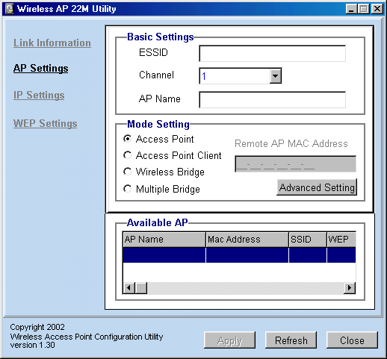
In the Access Point Setting menu, we can fairly similar set the ESSID, channel and AP name.

Planet Access Point has additional facility to set the mode of operation of the Access Point, either as Access Point, Access Point Client connected to certain Access Point, Wireless Bridge or Multiple Bridge.

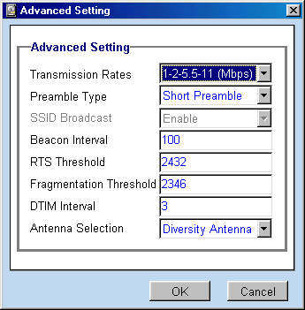
In the advanced setting menu, we can set more parameters. Some parameters are meant to increase the reliability of the communication link in a congested network, such as, RTS Threshold and Fragmentation Threshold. To enable RTS and Fragmentation mechanisms on the Access Point, we need to set the number lower than 1400 byte.

If you don’t want outsiders to spot the Access Point, we normally disable SSID boardcast.

Planet Access Point has two (2) antennas, we can set to use one of these antennas either the left or the right antenna. Diversity Antenna setting is used for utilizing both antenna simultaneously. It is normally used for in door operations.

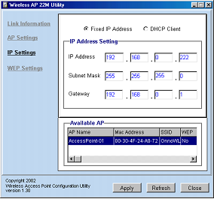TCP/IP configuration of the Access Point is quite straightforward through the IP settings menu. The default value is DHCP client setting. The Access Point will ask for IP address any DHCP server on the network.

In a WiFi infrastructure, we normally set a fixed IP address, subnet mask and gateway.
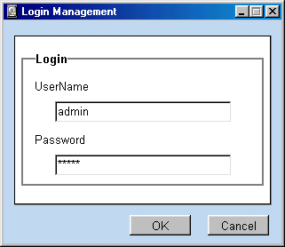

Before the setting is applied, it will ask for username and password for authentication. The manufactured set username and password are “admin” and “admin”, respectively.

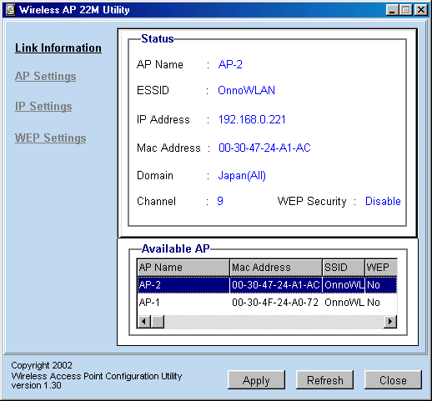

The Planet Access Point utility software will automatically recognize if there is two (2) Planet Access Point on the network. We can set each one of them separately by clicking the AP name in the Available AP table.

