MULTIMEDIA TRAINING KIT
Miscellaneous: Congested Network Configuration
Developed by: Onno W. Purbo

Configuration For Congested Network

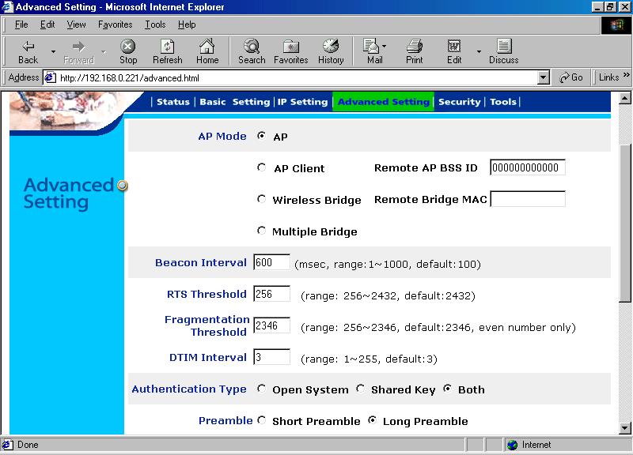
In a congested network that most likely to happens in outdoor WiFi infrastructure, we definitely have to set at least the RTS Threshold lower than the default value. In the example, the RTS Threshold may be set to 256 as shown in the figure for Planet WAP-1965..

The Request To Send (RTS) mechanism is working in conjunction with Clear To Send (CTS) mechanism. If there is packet larger than RTS Threshold going to be transmitted, the station will send a RTS packet to the destination. Similarly for other stations, those that are going to transmit long packet longer than RTS Threshold needs to send RTS packet to request permission to transmit the long packet. The CTS mechanism is basically providing a virtual carrier to inhibit other station not to transmit. Only a particular station that received the CTS can use the frequency and transmit the packet. By doing the RTS-CTS mechanism, collision on the frequency may be avoided.

RTS-CTS mechanism is an excellent solution to hidden transmitter problem. The hidden transmitter problem is the case when two or more stations that unable to hear each other wants simultaneously send a packet to the Access Point. If no RTS-CTS mechanism used, the packet from these stations will likely to collide. CTS packet from the Access Point for a certain station will inhibit others from sending the packet and, thus, reducing the collision possibility.

