MULTIMEDIA TRAINING KIT
Miscellaneous: Web Interface - Linksys
Developed by: Onno W. Purbo

A Glimpse on Linksys Access Point Web Interface

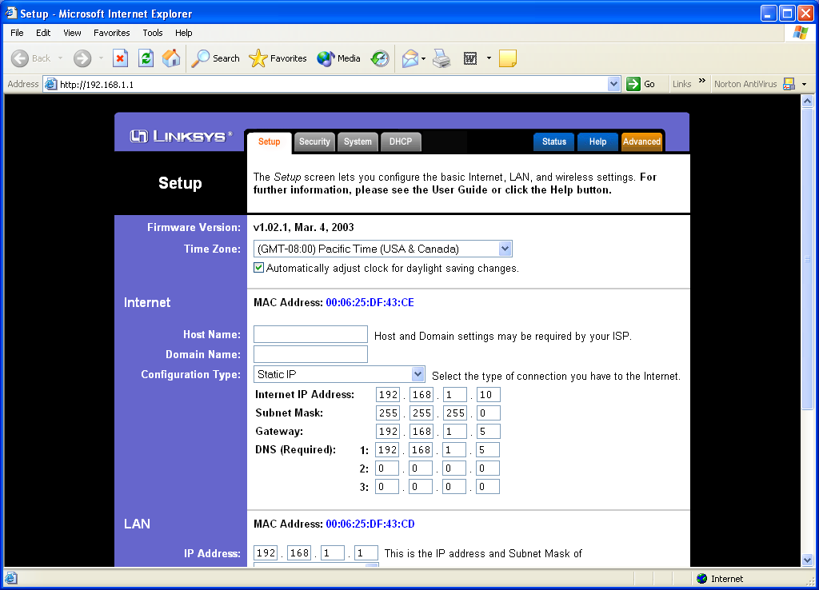
Linksys http://www.linksys.com is one of the favorite WiFi manufacturers. In this particular example, I use WRT54G Wireless-G Broadband Router. Might be worthy to note that the Linksys AP is a router, and this may change the setup of the Linux gateway. The Linksys can handle the network routing, and some features like DHCP. This will lighten in load on the Linux gateway, turning it into a server for the network.
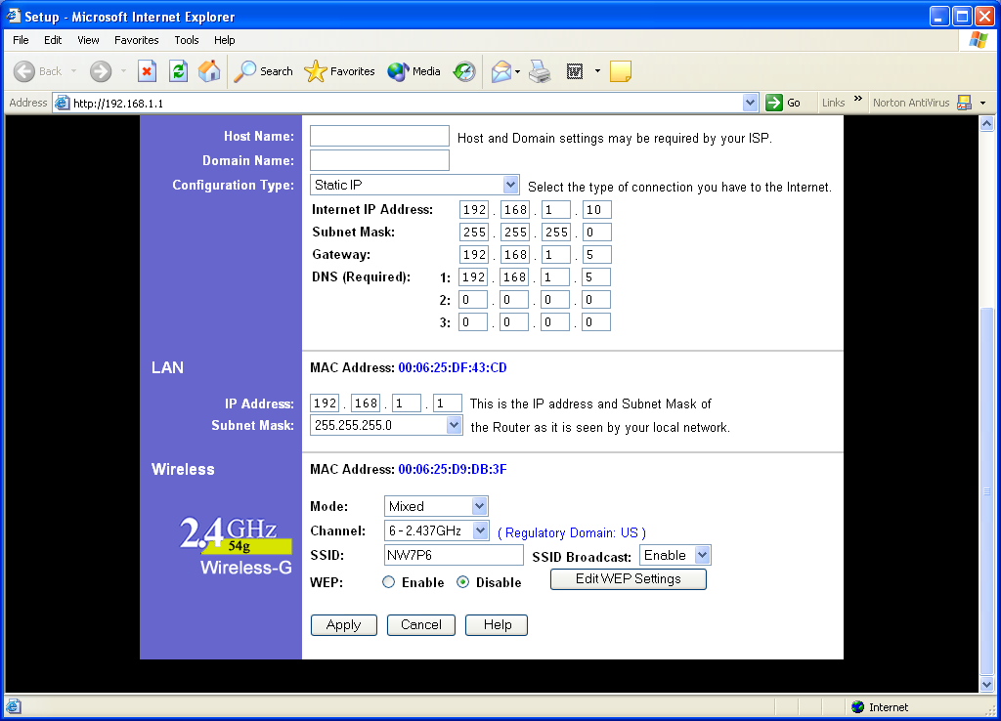
The WRT54G can be configured via a Web interface at default address 192.168.1.1 (if not changed). The first page is the setup page. Through setup page we can set the time zone, Internet connection configuration, LAN configuration, and wireless configuration.

Several connection types are possible in Internet Connection configuration, such as, static IP or automatic IP via DHCP from the ISP. In the figure it shows the static IP Internet connection.
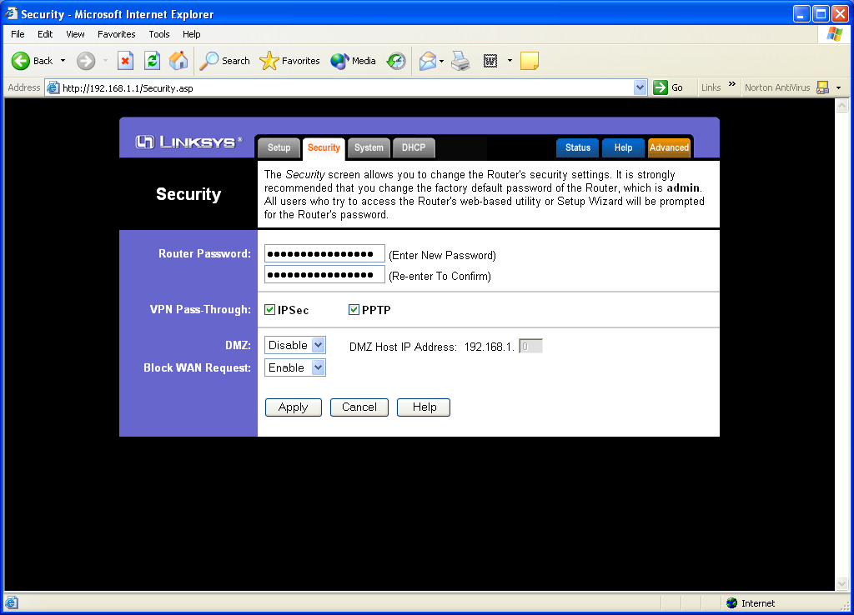
LAN configuration is fairly simple, all we have to do is set the IP address and the subnetmask.

The wireless configuration is fairly similar to other Access Point. We can set the channel and the ESSID of the equipment. To secure the Access Point, we can disable ESSID broadcast so that only the one that knows about our Access Point can access it. Wired Equivalent Privacy (WEP) encryption can also enabled at this point.

The next page is the security page, we can set several security related parameters through the page, such as, administrator password, type of Virtual Private Network (VPN) traffic allowed, configuring the De-Militarized Zone (DMZ) as well as a small scale firewall.

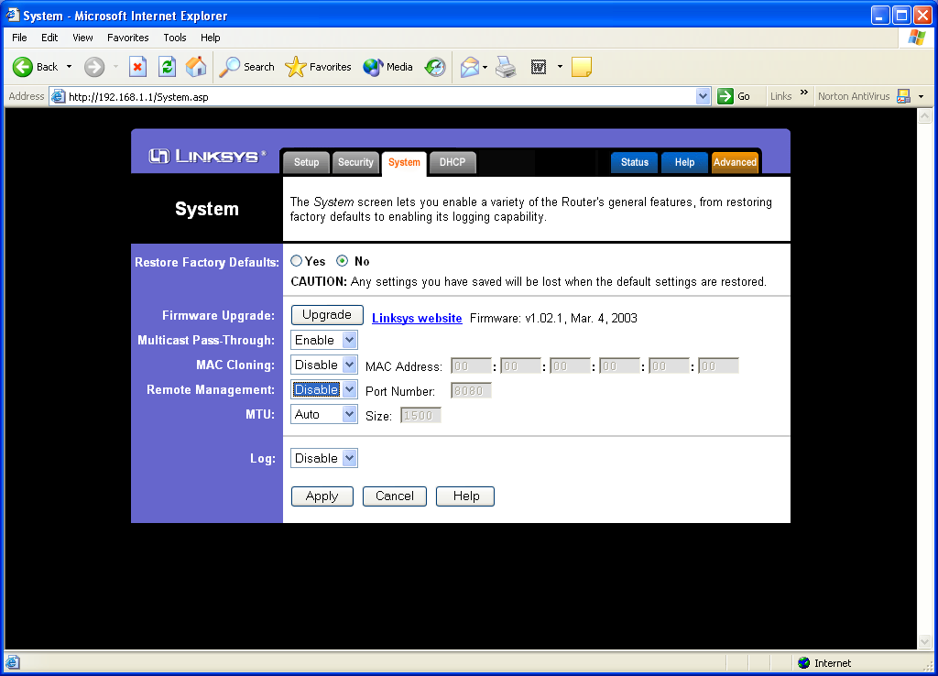
System page is the next page of the Linksys WRT54G Web interface. We can basically leave everything as it is. However, those who would like to upgrade the firmware, changing the Maximum Transmission Unit (MTU) of the interface, and enabling / disabling any multicast packet to get through, can be done through the System page.

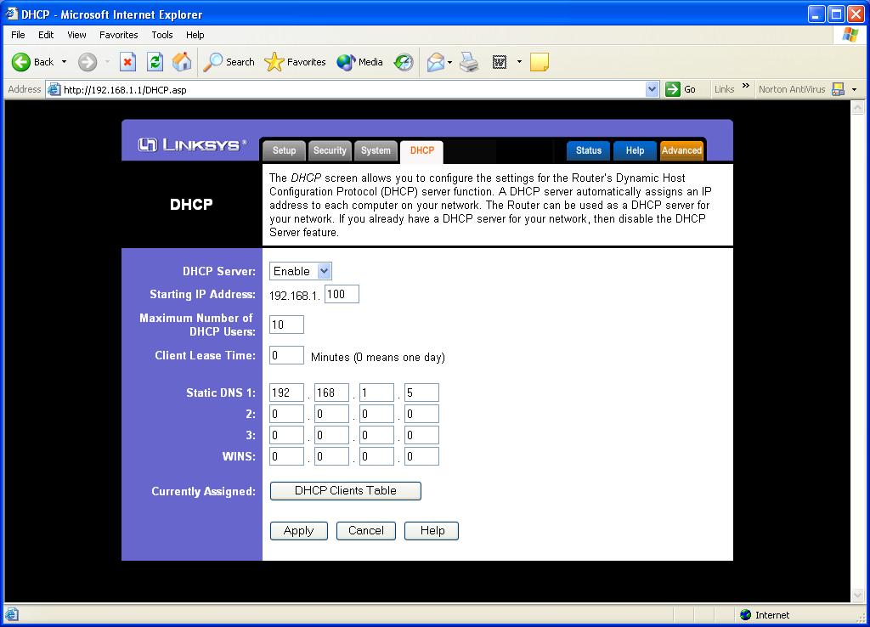
DHCP Server page is the next page. Linksys WRT54G Access Point has provided a built-in DHCP server in it. If we enable the DHCP server, the range of IP address to be allocated to connected workstation, the DNS servers, can all be configured.

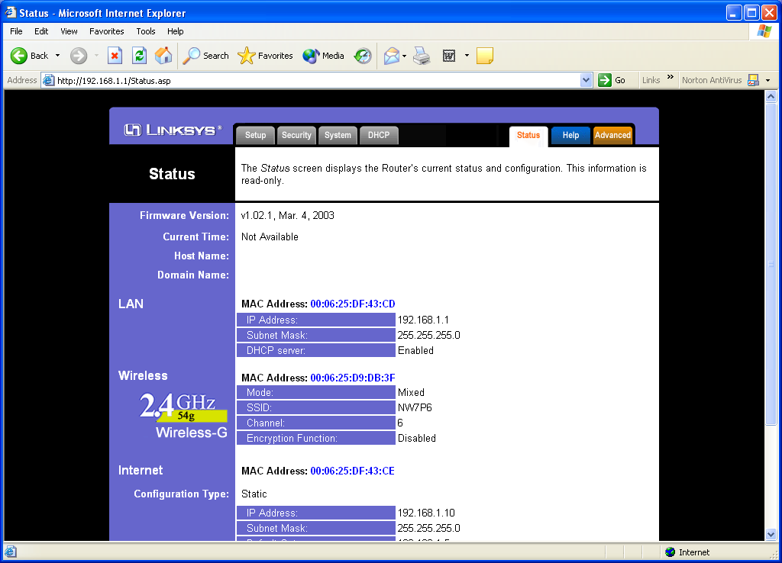
Most of the configuration can be reviewed from the Status Page.

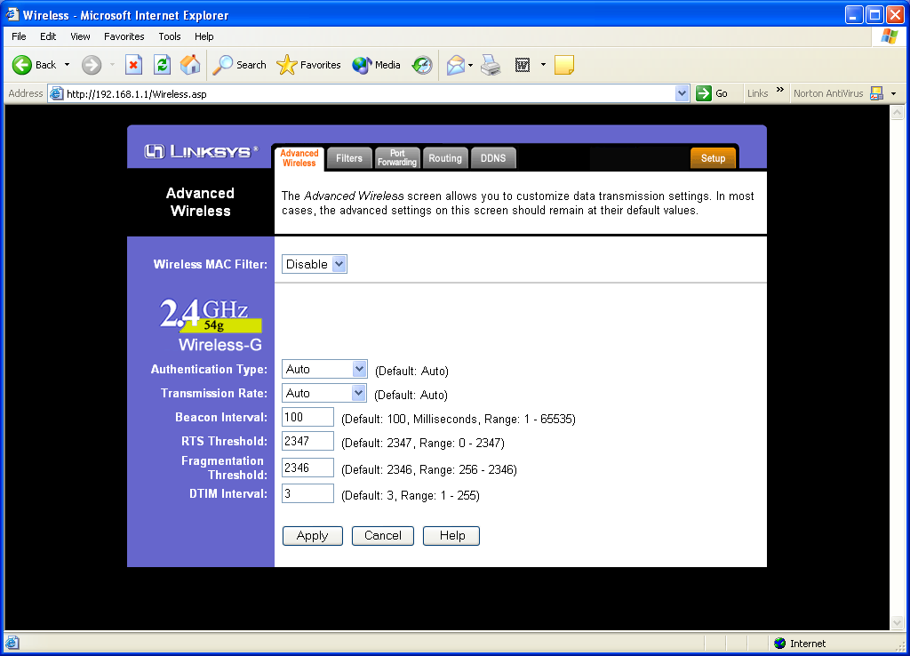
In the more Advances Wireless configuration Page, we can configure a more advance configuration settings, such as the RTS and Fragmentation Threshold for dealing with network congestion, beacon interval in broadcasting the ESSID of the Access Point, the transmission speed of the Wireless LAN.

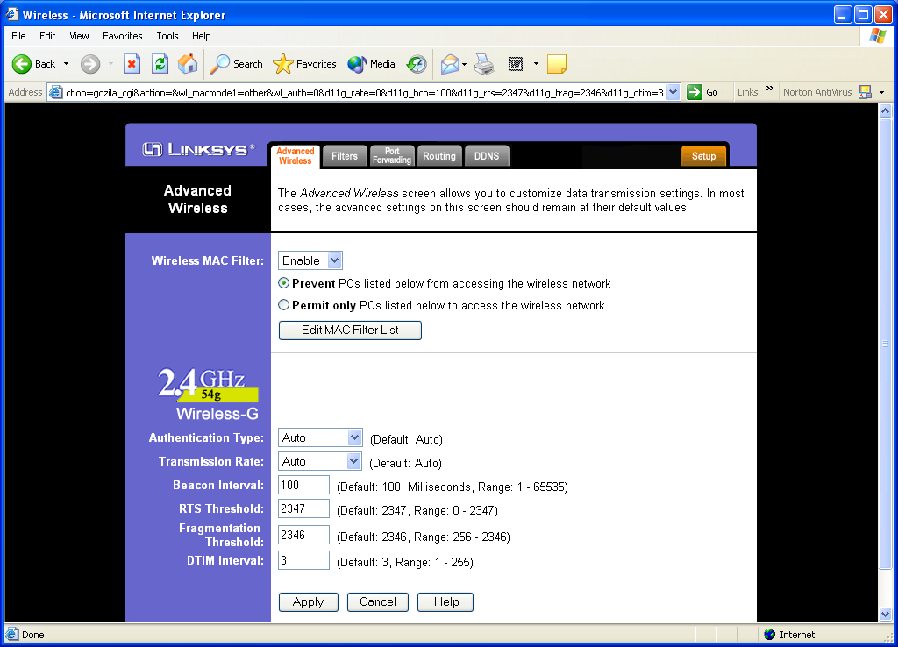
Within the Advance Setting page, we can enable the MAC Filtering table. MAC filtering can be used to limit the access to only certain known workstation / node to the Access Point.
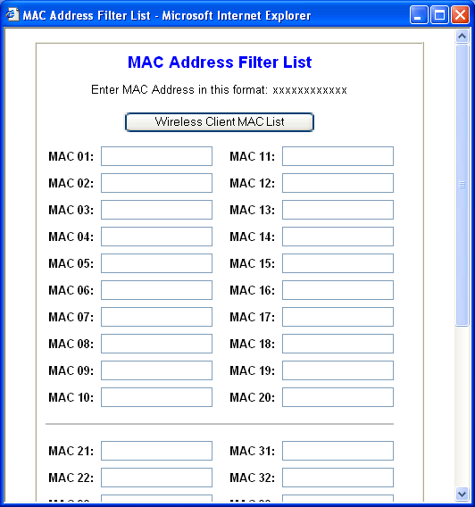
The MAC Table is fairly straightforward and can be completed by entering the MAC address of the approved client MAC address.

