MULTIMEDIA TRAINING KIT
Miscellaneous: Web Interface - Planet
Developed by: Onno W. Purbo

Web Interface
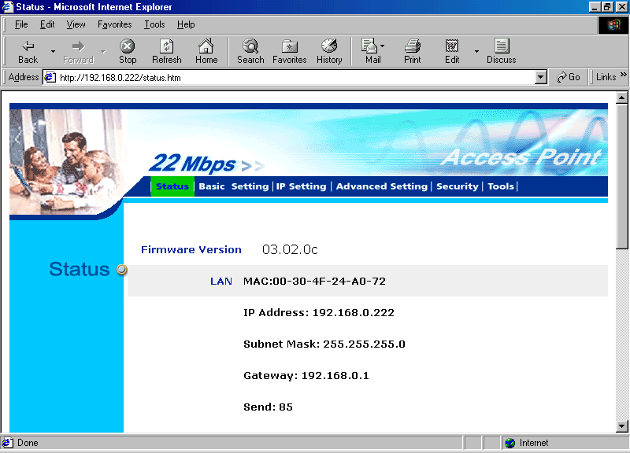
Some of the Access Points have the Web interface to configure it. Shown in the example is Web interface for configuring WAP-1965.

All the information on the current setting is shown in the status page. It will show the TCP/IP configuration, radio configuration as well as some statistics.

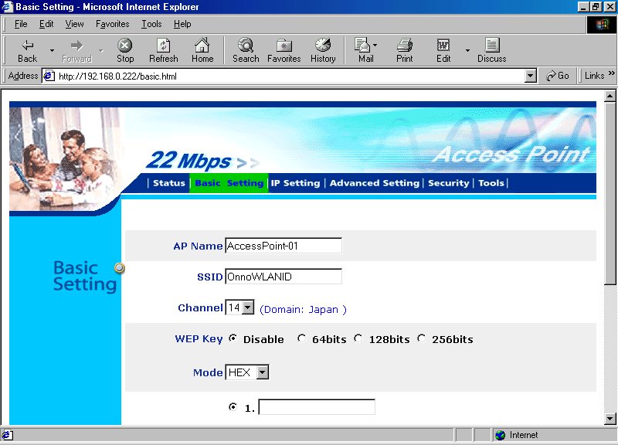

In the basic setting page, we can set the basic setting of the Access Point. These settings include the SSID, the AP name and the channel. If secure channel is necessary, we can set the WEP encryption keys through the basic settings.

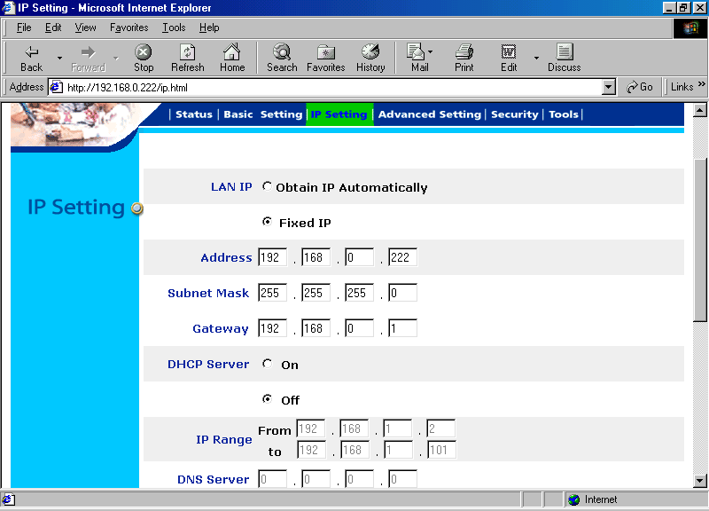

In the IP Setting page, we can set the TCP/IP configuration to either fixed IP or obtain the IP automatically.

An interesting feature of Planet Access Point, it has a DHCP server build in to automatically give a station an IP address. We can set the IP addresses range to be allocated to the connected stations.
In the advance settings we can set various things on the Access Point to tune its performance.
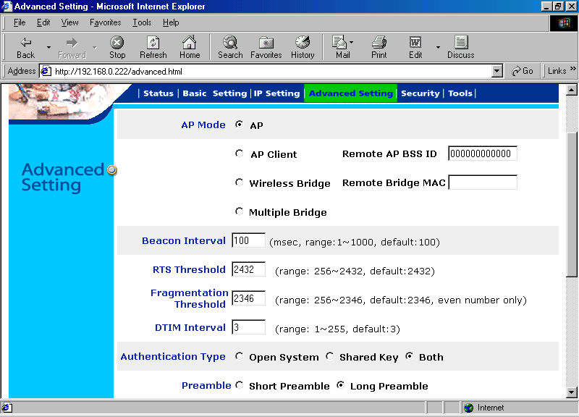
The Access Point mode can be set as either a normal Access Point, or a client of another Access Point, or Wireless Bridge for certain remote bridge, or work in a multiple bridge environment.

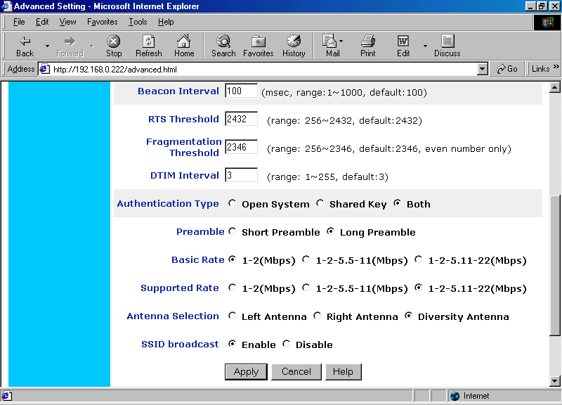
In a fixed wireless infrastructure with limited number of fixed client as it will likely to be found in outdoor WiFi installations, beacon from the Access Point is not necessary. Access Point’s beacon is primarily needed in hotspots or indoor installation where many WiFi stations are come and go many times. Thus, we can disable SSID broadcast. It will create a safer setting from intruder.

Request To Send (RTS) Threshold and Fragmentation Threshold will work if it is set to below the Maximum Transmission Unit (MTU) of the Ethernet card. The MTU is normally 1500 byte. Both Request To Send (RTS) and Fragmentation Threshold are normally used inn a congested network. Fragmentation Threshold sets the maximum byte in the packet sent over the air. If the packet length is longer than fragmentation threshold, the Access Point will fragment the packet into smaller packet with maximum length of fragmentation threshold. At the other end, the packet is reassembly into a single packet. Such fragmentation is needed to increase reliability in a congested network.

In the advance settings, we can also set several other parameters, such as, the rate of the modems, antenna selection, authentication type either open system or shared key or both, the length of preamble bits. Short preamble is normally used in a reliable indoor installation. Long preamble is normally used in unreliable especially outdoor installation.
In the security setting, we can set the administrator username and password.
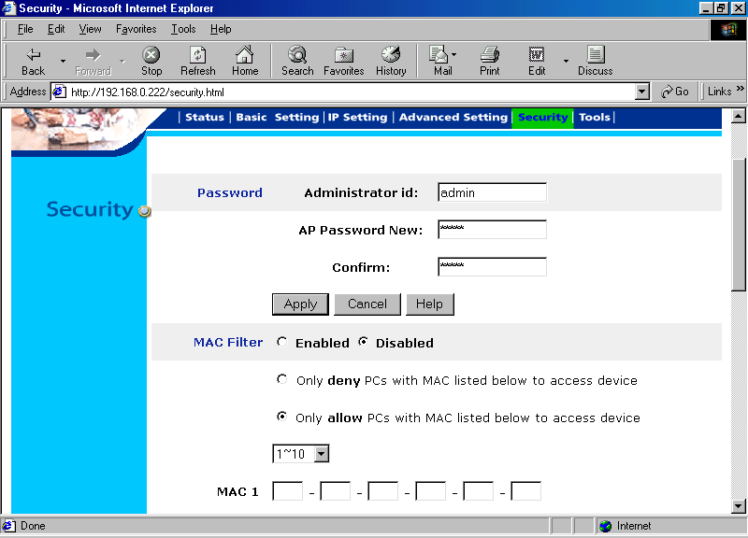
MAC filter can be enabled and set through the Security setting. We can filter the Access Point to serve for only certain WLAN card with certain MAC address. MAC address of the WLAN card can be easily found on the back of the card, or through various command on the operating system, such as,

- Winipcfg in Windows
- Ifconfig in Linux

