Laboratorium Komputer bagi Sekolah Informal Anak Jalanan
(Computer Laboratory for the Street Children's Informal School)
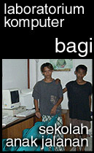
The Background
Every human being, no matter what their social status are, has his or her own rights to acquire knowledge. Every kind of knowledge, including computer education and the internet, must be reached for those who are living under the poverty line or those who cannot afford it. That includes the street children, the children who are living out there in the streets of the city, in Jakarta.
Unfortunately, the social system in our country tends to narrowed the access for those children to fulfill their needs for education and knowledge.
Therefore, the Center for ICT Studies Foundation (ICT Watch), ERa AKu NGO (Non-Governmental Organization) and Jaringan Informasi Sekolah (JIS) / the School Information Network, have made an effort to set up a computer laboratory. The computer lab, which is supported by donation from many institutions or personals in Jakarta, can be used freely for applying many kinds of computer training program for the street children. The computer laboratory is using the second-hand computers, donation from Bali Bank.
Now, the computer lab is finally installed at the Sekolah Anak Jalanan (SAJ) / the Street Children's Informal School, located on Taman Ismail Marzuki (TIM), Jakarta. The SAJ itself is run and monitored by volunteers from ERa AKu NGO. While the lab's maintenance and development is provided by ICT Watch, conjuctionally with JIS.
The Development
ICT Watch, JIS and the volunteers from ERa AKu NGO will continuously developing training programs on the lab. The training will be divided into two parts; a training program for the volunteer themselves, and programs for the children of SAJ.
The training program for the volunteers is addressed to them, so they will be able to operates the computer for many humanity activities that they done, including the ability to train the homeless children in using computers. While the programs for the children will be focused based on their ability and needs, adjusted with the situation and condition they faced on their social life.
For those who are below 15 years old, will be introduced to edutainment (education and entertainment) and beginner's program, such as computer program on playing with words and numbers, and also storytelling. And for those aged above 15, the program which more suited to them are the application program, the knowledge they can apply to everyday and work life, such as word processing program. Hopefully, such knowledge will become an additional tools for them to get a decent job.
Someday, we hope the computer lab will be able to get free internet access, so the program can be broadened to internet area. With internet access, we will be able to build a "warnet singgah" concept, an access center for the humanity volunteers to get information on the internet with very low cost. In turn, the access center will have additional income to support the cost, such as electricity, the SAJ operational, and hopefully can help to reinforcing the children so that someday they will be able to stand on their feet.
For those who care, and are willing to help and support the homeless children's education or have some kind of solutions to get free access for the SAJ (including telecommunication infrastructure and the bandwidth), please contact us by email at program@ictwatch.com.
Thank you very much for your attention and support. We really appreciate it.

Some Documentations

a.  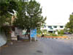 | b.  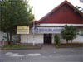 | c.  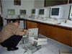 | d.  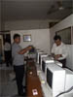 | e.  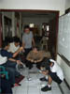 | f.  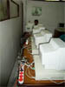
g.  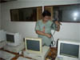 | h.  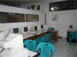 | i  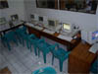 | j.  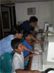 | o.  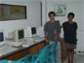  volunteers needed to empowering  children of the nation
k.  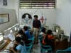 | l.  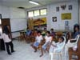 | m.  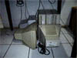 | n.  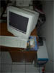

picture information:
a. SAJ point of view 1  b. SAJ point of view 2  c. ICT Watch & JIS team installing the PC 1  d. ICT Watch & JIS team installing the PC 2  e. ICT Watch & JIS team installing the PC 3  f. The "backyard"  g. Cabling | h. Lab's view 1  i. Lab's view 2  j. Street children are very exciting using the PC  k. Class of the older student, from waitress to student from poor family  l. Street children, playing and learning  m. 3 second-hand PC for stock from Bali Bank  n. 1 brand-new PC as a server from donatur

Member of Instalation Team
Donny B.U. (ICT Watch)
Bona Simandjuntak (ICT Watch / JIS / SMK Jawis II JKT)
Siswantoro SG (JIS / SMK Cahaya Sakti JKT)
Adel Bahrum (JIS / SMK 22 JKT)
Rahadin Ringo (JIS / SMK 46 JKT)
Sindu Irawan (JIS / SMK Jawis II JKT)
Doni (JIS / SMK Tridaya JKT)
--- ict watch / august 2002 ---

