Alternative Path For ICT4D

Onno W. Purbo
A Common Indonesian
onno@indo.net.id

Overall Perspective

This report is based on my personal 10+ years experience in attempting to build a financially sustainable community based information infrastructure in Indonesia. To start with, no available funding is assumed. I may very much bias to my Indonesian experience. All activities are driven by a simple vision, to see a knowledge-based society in Indonesia. ICT is believed to be the tool of choice to accomplish the task.

Maintain a self-finance & sustainable process under intervention of international bodies or donor agencies is the most difficult task. Most people will likely to assume that international bodies would likely to bring free funding for them. It may work for pilot projects; the process may unfortunately stop as soon as the funding source dried up.

Similarly in most government approaches, bridging a digital divide with imbedded divide policy framework (operator vs. common user) and no room for community-based infrastructure seems to be arguable. Not to mention the highly corrupt environment. Significant part of the existing regulatory framework became an obstacle against our effort intended for people’s movement, and, thus, leads to unnecessary casualties in some cases.

My experience shows that it would be much easier to initiate a self-finance sustainable process if there is no funding from any donor agency to begin with. We can easily see the committed individuals & successful approaches in a free donor agency zone. Care has to be carefully planned to inject funding in a self-finance & sustainable process. Key successes rely heavily on ability to create a tacit knowledge exchange platform enabling knowledge producing young authors follow up by education processes focused on scaling & replicating the process for high impact to the society. Open source, open document, copy left movement would be significant. All processes are self-finance. It has nothing to do with the technological superiority of the equipments. Adjustment should be made for different countries & regulatory environment.

The catch would be in the ability to identify & to work with informal (most likely underground) visionary leaders / pioneers in the country / area. It would unfortunately be very difficult to find one through formal (government) channels.

Intervention from International Bodies / Donor Agencies

International bodies or donor agencies may speed up the scaling up and replication processes in society movement. In a clean environment with not much corrupt government officials, a direct intervention to government regulatory and policy framework & do e-government might be one of the fastest ways to get the result. Assuming they have a large number of “clean” law enforcement. My apology, in Indonesia, such intervention may not likely to work.

A careful intervention should be performed in one of the point in demand creating processes. It can be in

- 2-way interaction platform – to accumulate & manage community tacit knowledge.
- Information analyzing & synthesis processes. Testing & development processes.
- Encourage explicit knowledge creation, e.g., in book and article.
- Expedite explicit knowledge distribution.

Those are the processes that involving a large number of people. It is a long-term process, with very limited interest from commercial sectors to sponsor the process. Thus, it is not surprising the see these communities rely on Internet free services, such as, yahoogroups.com to facilitate their process.

Just to give some ideas on the kind of intervention by donor agencies to facilitate the process without disturbing the self-finance & sustainability process of the movement, some of them are,

- Creating free mailing list platform at the country’s Internet Exchange in confining the discussion traffic bandwidth in the country. It might be possible to work together with yahoogroups.com (http://groups.yahoo.com). To be honest, it is a good free mailing list service in the world today.
- Some sort of Slashdot or Source Forge platform for the developer to test their idea, their software, their script and share it with others. For example, a lot of young Indonesian developers ask me if I have access to free web server with PHP & MySQL capability to test their script. If such approach would like to be performed, we can set the condition for these young developers to publish & share their work under GNU license if they use the server.
- Having some sort of ICT book competition to encourage young authors. It may inspire others to produce explicit knowledge.

Language barrier would be one of biggest barrier in south-south development strategies. I personally don’t know the best solution to such barrier.

In addition, in all intervention, it is important to monitor the reaction, get feed back and interact with the community through various mailing lists. It is very important to have an intense interaction with the community. It would be difficult to move the communities by keeping some distance (namely less or slow interaction) with the communities.

Typical Indonesian Government Approaches

Typical Indonesian Government approaches

- Set idea & surrounding issue of an important idea, e.g., ICT infrastructure for rural, e-government, regional autonomy, and decentralization.
- Spread the idea. Organize many seminars, workshops, and videoconferences with many International bodies through out the country.
- Do piloting. Getting some funding for pilot project & run the project to show the results.
- Get the loan. Proposed loan for larger scale implementation.
- Set the policy & legal framework to privatize & to liberalize the market.
- Promise for the best. Deliver nothing.

Such approach may be the most appropriate path for clean and committed government. In a heavily corrupt government, such approach is unfortunately just another way to propose a project and getting at least 60% of it into the official’s personal account. It is a painful nightmare for those who live in the country. A corrupt environment will unfortunately impede government ability to reach their objectives / vision if any.

Some examples in ICT area, all of which would normally based on the premise that the government is financially & technically far superior to the common people, which is not totally wrong.

- Setup a national ICT vision; do some need assessment & return on investment calculation; submit proposal to the Bank; getting the money and spend it for writing policy / regulatory framework or some pilot projects. Hopefully, it may sustain. A "good" example is the World Bank's funded US$ 34,5 million Indonesian Information Infrastructure Development Program (IIDP) that was approved in November 1997. There is no grant & charity in the commitment. The project closing date is 06/30/2003. To be honest, from IIDP Project, nothing is left for the Indonesian people. Unfortunately, the Indonesians have to return the loan ☹ …

- Setup regulatory framework for privatizing and liberalizing the market. Privatizing the Indonesian Telco creating abundant problem in the field as they buy the government, less need to serve the customer, tends to delay investment for a better tariff. Licensing is a way in liberalizing the market. In the implementation, it may be used as financial compensation for the officials, no room for homebrew equipment. Note that not much room for community based infrastructure possible within the current policy / regulatory framework.

Alternative Financially Sustainable Community Based Movement

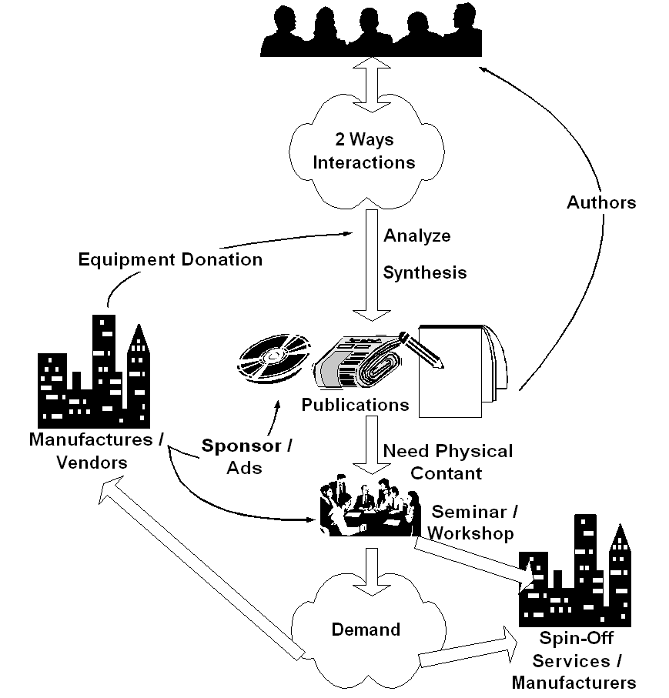
To sustain a digital divide bridge deployment, a supply created-by-demand strategy would be crucial. Most failed approaches will likely to use demand created-by-supply path. Demand in information infrastructure as well as ability to exploit the abundant information & knowledge in the infrastructure will only happen in an educated society. Failure to increase the society's level of education will likely to impede the development of information infrastructure within the society.

Key success in deploying the information infrastructure would rely heavily on the quality & skill of the human resources. Ability to distribute the needed knowledge & skill at low cost would be crucial in creating demand & needed skilled technician to deploy the infrastructure. Ability to access ICT knowledge in English would be a plus. Interestingly, please note that funding is not the primary concern in deploying ICT infrastructure.

If I may put it in point form, the simplified steps would be something like,

- Create platform for people to do 2 ways interaction. It is basically to facilitate tacit (implicit) knowledge exchange. It may be radio or TV talk shows, or Internet mailing list at no cost. Unlike most assumed condition by 1st world countries, no abundant local content is necessary to start with. Community will create their own content through platform the exploit community implicit knowledge.

- It may take 1-2 years, before some of the individual start analyze and synthesis the collective community knowledge. These young individual should make their knowledge implicit in written form. It should be distributed through conventional channels, such as, newspaper, magazine, radio & television, and thus transform the mindset of others who are not yet using ICT. It cost US$ 1-2 to access the knowledge by buying the book or magazine. They will produce publications in magazine and books and receive US$ 25 / article or US$ 500 / book.

- Some may need physical contact through seminar and workshop to be convinced. We are normally looking at 500-1000 participants / seminar. It costs US$ 3 / person to enter such seminars as many vendors may likely give sponsorship.

- Creating demand within the people for the "digital divide bridge". Once the demand increases business will respond to the opportunity else persuade people to invest their money into deploying the "bridge". A 50 cents/student/month in a school network or US$15-30/house/month in a US$2000 neighborhood network investment with RoI within 1-2 years is a good enough incentive for people to invest their own money into the "digital divide bridge". Success stories & word of mouth is the typical process to spread the words.

- Deploy & maintain the "digital divide bridge" may be done at 50 cents/student/month at school or about US$ 15-30/month/house. Ah, we finally have financially sustainable digital divide bridges with minimal support from the Bank, the government & hopefully license free.

- In the end, as more and more people connected to the Internet, pressure will be high for the regulators to work on their policies. Hoping no distortion made during the processes.

As shown clearly, all the sequences are self-finance. The normal (not the ideal) sequence would be awareness, demand, business response, and regulation. These steps would not be completed over night. It will take years to complete these steps. Committed leaders & personals are needed for such long-term deployment ICT movement.

Having an alternative bottom-up self-finance community based movement has proven to be a good ICT development model, at least for Indonesia; as a result, we are currently seeing:

- 4+ million Indonesian on the Internet
- 2500+ WiFi outdoor node for bypassing local telco infrastructure
- 2000+ Internet Cafes
- 1500+ schools on the Internet

Note that most of these results are community based funded with not much government support; as well as no funding from World Bank or IMF.

Some of the Trick To Facilitate Local Content Creation

Having the demand-created is one issue, we need to build the surrounding skilled / technical infrastructure to support the deployment of the "bridge". Local expertise and local content generation would be crucial in the process. Against most 1st world perception, no initial local content is necessary to start with. It is not difficult to start the process with no initial local content.

I wish the country’s university curriculum & lecturers have an up to date ICT knowledge. In a fully centralized public education system, inserting new technology into the curriculum would be a major headache. One may surprise to know that skills in WordStar & Lotus 123 are required in computer science undergraduate program. Having an aging curriculum in many IT schools / universities, it would be better for the students not to listen to their lecturers rather finding their knowledge through the Internet facilities in their schools.

I normally use a subtle approach within the Indonesian university student communities to interact with them through many talk show / seminar activities. Try to encourage the students the leave their stage of being an ICT knowledge consumer and transform them into ICT knowledge source in Indonesian language. Such approach seems to work, there are currently many young ICT writers in Indonesia & publishing their books in Indonesian language to get some money for their tuition fee.

If I may put the simplified steps into point forms,

- Access to abundant ICT information, knowledge & skills in English by many Indonesian students / professionals over the Internet. A significant number of Internet Cafes & wired universities help the access. It normally costs about US$0.3/hour in most Internet Cafes.

- Activate many technical discussion groups / mailing lists on the Internet using local language, e.g., using yahoogroups.com, to enable tacit knowledge transfer among local techies for free.

- It creates demand for ICT magazines; good for the publishers. There are currently a significant numbers of local language ICT magazines that will accept local contributors. The magazine sells at US$1-2/magazine. Encourage the students to publish their work in these magazines; payment of US$15-25/article is good for paying their tuition fee & living cost while educating others.

- A more technical discussion will likely be written in books in local language. Experienced writers will likely to write books & transform oneself into knowledge source in local language. A royalty of US$700-900/book, that would normally completed within a couple of weeks, is a good incentive for people to publish their knowledge while again educate the society. There are currently so much ICT books publish in Indonesia. It costs about US$2-3 / ICT book in Indonesia. As of the writing of this manuscipt, one of the publishers, namely, PT. Elexmedia Komptindo (http://www.elexmedia.co.id), receives backlog to publish manuscript far into year 2004.

- In most cases, reading articles books or discuss over the Internet is not enough. Physically see the author / the expert in person is needed. With US$3-5 / person, one can participate in many tutorials, seminars, installation demo organize by many event organizers / institutions in the country. It is not surprising to see 500-1000 people shown up in most tutorials & seminars. Many vendors & sponsors will likely to participate in such high attendance list. A full fledge workshop may cost more about US$20-30 / session. A US$50-100/hour or /session compensation for the speakers is a very good incentive for most of us.

- Some of us are currently working on creating VCD in ICT education. Others put their work on the web for free download. As Internet access is quite expensive in many areas, CD distribution of the knowledge as well as many open source / Linux is helping the knowledge dissemination processes.

- Radio, television and newspaper are helping the process especially for user level, but not really in technical skills.

Again, if we look at it all process would be very much self-finance and self-propelled. To give some more extreme ideas, we can actually mingle with current education system. For example,

- When I teach at Institute of Technology Bandung, I remove the necessary attendance. No mid term exam. No final exam. Mark is given based on their ability to become a knowledge producer. A simple example, forcing the students to publish article in the magazine, e.g. 5 articles A, 4 articles B, 3 articles C etc. or publish a book for an A.

- Other way to encourage the students, I give free access to the Internet for those who like help me maintain and run the system. In the end, I ask them to write book based on the knowledge gain during the process.

- The private sector will be gladly helping us in performing the process as we create huge demand for their products. Getting free equipments to do the experiments is not that difficult. Most companies would be interested in sponsoring the seminar / workshop if there are 500-1000 people showed up.

In these processes, we force the young students to become a knowledge producer to benefit the whole society through local knowledge accumulation.

In rural and remote areas where talk-and-listen is the primary communication means, computer & Internet based ICT may not work well. Community radio and television might be the best alternative. One can easily build a community radio transmitter for under US$100, and, thus, enables its surrounding community to speak up and creates an information-diversity environment. A network of community radio would be a strong barrier against information domination by national / multinational broadcasters. We unfortunately have to fight again with the local government for frequency allocation.

