A Glimpse On Internet Telephony (VoIP) Infrastructure

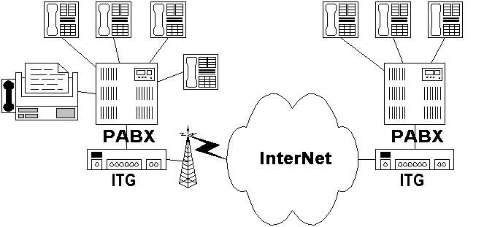
Having a US$15-45/month/house for 24-hour Internet access using WiFi-based outdoor infrastructure. With a total investment US$250-300 per WiFi gateway, or about US$25-30 per neighbor is the driving force behind the deployment of many community neighborhood network.

Having 24-hour Internet access, the logical next step would be Internet telephony. Voice communication is still a dominant mode of communication in developing country like Indonesia.

We normally use Internet Telephony Gateway (ITG) connected to a small PBX to share the telephony to an office or neighbor.

How does Internet Telephony help ICT for Development?

Let’s review the cost. a typical Internet Telephony Gateway (ITG) with four (4) ports would cost about US$400 each. The ITG will translate conventional voice traffic into VoIP traffic over Internet infrastructure.

To reduce the investment and operating cost, we normally connect the ITG to a Private Branch Exchange (PBX) and share the VoIP lines with more people in the office or neighbors. Thus, it is normal to connect all four (4) ITG’s port to PBX. A typical PBX, such as, Panasonic KX-TA616 has 6 CO lines and 16 extensions. Panasonic KX-TA616 may cost around US$400-500.

Thus, the investment cost would be around US$800-900 / 16 extension or about US$50-60/extension. We can reduce it by using low-cost equipments.

Thus, the US$20-25/month/neighbor can now include an “unlimited” long distance calls over the Internet to other community-based network.

