Laying Out Trajectory For Digital Divide Bridge

Onno W. Purbo, Indonesia (onno@indo.net.id)
Independent Information Technology (IT) Writer.
Eisenhower Exchange Program Single Regional Program 2002.

To be honest, I am not considering myself a leader. My only hope is to be able to give away as much of my knowledge to the Indonesian people and contributes on their transformation towards knowledge-based society.

The digital divide has never been about just access to computers: it is also about education and opportunity. If every family in every community had Internet access tomorrow, the digital divide would still be there because access to technology is useless without the computer skills needed to really take advantage of that technology. In addition to access, people need knowledge and competence in a wide variety of computer skill areas.

The Eisenhower Fellowships program shows the significance of telecommunication and information technology infrastructure in empowering US rural and underserved areas. Putting technology in place is the easiest part. People, its education, social, cultural, politics, and policy aspect would be the most challenging part. Build the usefulness of technology into the values of the culture would ease the acceptance processes.

Overwhelming information and knowledge acquire in the fellowships significantly enhances my point of view on America. Having focus on rural and underserved Americans, it yields many genuine best practices in building the bridges to narrowing the digital divide. The prior vague path becomes much more clearer as interaction goes. I found many best practices learned in rural and underserved America are very much in line with potential solutions needed in Indonesia.

Several major key findings found during the fellowship, namely,
- Education! Education! Education! Education is the heart of transformation processes.
- Youth is the agent of change.
- Accountable leaders may catalysts transformation processes.
- Putting technology in place is the easiest part. Its social, politics, policy, cultural issues may create the unnecessary barrier. Build the usefulness of technology into the values of the culture would solve.
- Demand-created supply scheme works best as compared to supply-created demand. It is an art in itself like chicken and egg, which comes first?

Values (an exert from Strategic Plan of Technology Access Foundation)
- technology and life skills - technology skills are as important as reading, writing, and arithmetics. They are building blocks for the future. while specific technologies change overtime, the need for solid life skills remains constant and is critical element to success.
- access to opportunity - skill are best used when opportunity presents itself.
- strategic and collaborative leadership & partnerships.
- fiscal responsibility and sound business ethics – one should conduct their business with integrity and fiscal responsibility.
- continuous improvement and learning - no matter how successful we may be, there is always room to learn more and improve.

To prepare the next generation, children in our communities need the following to have a chance at a successful future:
- a solid foundation in math, reading, communication, problem solving, and critical thinking skills.
- computer fluency skills (operating knowledge, desktop tools, internet use, and basic programming skills).
- information literacy skills (searching for, organizing, synthesizing and producing information).
- educational and employment opportunities.
taken together, families, community organizations, schools, businesses, and governmental organizations possess all the necessary resources to develop an environment where our childern can succeed. Those who wants to take an important role in providing many of the resources needed to ensure our chilldern's success, must be able to work with all the above stakeholders

Some interesting informal education approaches,

- Computer fluency and information literacy skills would be best to be introduced in early young kids. Play while you learn seems to be an excellent approach. I talk to these young ones (6-7 years old); it surprisingly takes them minutes on the Internet to find the answer for the questions ask by the teacher. One of the major difficulties for the teacher as well as the curriculum designer is putting the learning concept in layman words. It is the most difficult part in most education processes. Boys and Girls Club of America (www.bgca.org) might be a good example of such activities.

- Technology access foundation (http://www.techaccess.org) might be one of the most impressive example aims to strive teens to have a chance at a future success. Demanding programs require a dedication, discipline, and high motivation provides the required solid foundation, computer fluency skills, information literacy skills, educational and employment opportunities. A milder program can be found at Pennsylvania Service Learning Alliance www.delawarevalley.org/psla/index.html where high school students learn refurbishing old computers and help their surrounding communities as well as their own teachers.

- For a more general communities and adults, several type of Community Tele Centers (CTC) provides free, or at least low cost, community education. Continuing education and practical computer skill classes are common, and hoping to be able to add values to adult communities to gain a better life especially in poor neighborhood. It is interesting to note that providing free education is not that easy, quite high resign rate occurs in such classes due to various reasons. Networking and support from various organizations on community centers, are apparent. One of such networking and support center is the CTCNet www.ctcnet.org. Examples of visited CTC are Oregon Public Network (www.opn.org) and St John’s Learning Center, Columbus Ohio. One may find the needed teaching materials online, such as, in www.contentbank.org.

- Coaching the leaders supported by IT training for the technicians as demonstrated by Widernet (www.widernet.org) would significantly help the expansion of the country’s Internet infrastructure.

These interesting approaches would be possible to be implemented in Indonesia. However, as number of people requires such help is order of magnitudes as compared to the US, our major problem will likely in,
- Finding a large number of passionate and dedicated people & volunteers who like work and help others.
- Access to knowledge, ability to read in English would significantly be needed by these trainers.
As far as the regulation and policy goes, not much stumbling blocks would be find in our ways.

In rural, underserved and poor neighborhood areas, alternative ways in building infrastructure are learned. Some examples are,

- The US Department of Agriculture www.usda.gov/rus/ is encouraging the flourished on independent telephone companies and cooperatives. In 2002, there are approximately 1,000 independent telephone companies / cooperatives in the United States. The National Telecommunication Cooperative Association NTCA http://www.ntca.org is becoming one of the vocal points of these independent telephone companies. NTCA's more than 500 telephone cooperative and commercial companies have more than 3.1 million subscribers. The average number of access lines among NTCA's members is 4,000. The customer bases of NTCA members ranges from less than 100 to more than 50,000. The average number of employees among NTCA's members is 23. Approximately 2 million rural residents are served by telephone cooperatives in the United States. Bell operating companies, on average, serve 130 customers per mile of line. In contrast, the highest teledensity among NTCA members is 7 subscribers per mile of line, and on the low end, one customer per 10 line miles. Interestingly, as these independent Telco are such as small companies, agility to adopt and deploy new technology is much better than the incumbent Telco. It is not surprising to see DSL lines and fiber optics to American rural.
- As demonstrated by Lane County in Oregon State, ability to negotiate with fiber optics carrier running across the country to provide access to rural areas would be of significance. Management of the fiber may be done by a consortia set within the community.

- Low Earth Orbit (LEO) Satellite, such as, the one run by VITA http://www.vita.org, is one of the alternative solution for rural areas. A compact, plug and play ground station currently being built enable rapid deployment. At 9600bps, store-and-forward email-based system for LEO Satellite provides each station with 350Kbytes of data transfer. Web mail access, such as, the one to access VITA database, is an interesting approach especially for remote / rural areas with low throughput network. With multimedia data transmission capability and 5% of total WorldSpace bandwidth at its disposal, the WorldSpace Foundation's Learning Channel is a valuable communication resource for developing countries. Other terrestrial wireless solutions, such as, WiFi, would also be an interesting feasible alternative for building the alternative infrastructure in 3rd world country.

- Bandwidth would be very precious in most 3rd world countries. Delivering hundreds of thousands of digital documents to 3rd world countries on low cost 120+ GByte hard drive, and, thus, significantly trimmed down the dependency to the Internet as demonstrated by the WiderNet Digital Library Project (http://www.widernet.org). Work is currently underway to deliver the update of the materials via World Space digital satellite radio.

- Providing resources for helping the deployment and integration of appropriate technology would be essential. Such resource center to provide pro bono technical and engineering assistance to international networking initiatives providing access to the public Internet has been demonstrated by the Network Startup Resource Center (NSRC) http://www.nsrc.org and VITA Connect http://www.vita-connect.org.

Deployment of most described infrastructure will likely to face significant policy and regulatory challenges. Shift in mind set within the policy and regulatory framework would likely be needed that,

- All policy and regulatory framework must aim to fulfill the right of communication and access to knowledge.
- Concept of privatization and competition may create the needed constructive environment that should be balanced by empowering and funding rural and underserved communities' infrastructure.
- Bandwidth and frequency management must aim for the benefit of the majority of people. In most cases, ability to provide free public access would be paramount in facilitating the people transformation processes towards a better stage.

Lesson learned in knowledge transfer processes as well as infrastructure deployment may be adapted into Indonesian condition. A simple picture of the digital divide bridge layout in Indonesia is shown in the figure.

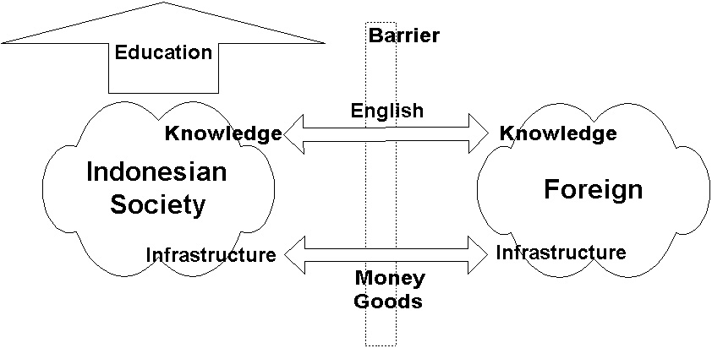

Education especially among young Indonesians is the most strategic key process to transform the Indonesian people towards knowledge-based society. Ability to read and write in English would be very essential in gaining the required knowledge. As for the infrastructure, a rapid flow of money (capital) and goods between Indonesia and Foreign countries would be essential. Unfortunately, within the current Indonesian condition, a significant policy and regulatory challenges will be prevailed especially in the infrastructure. Hoping the shift in mind set within the policy and regulatory makers can be performed within a short transient period for a better Indonesia.

Well, the bridge may not be perfect as …

"Life is like driving a car at night. You can only see a few dozen feet ahead - as far as the headlights. But you can make the whole trip that way."
Richard Vohs, CEO Iowa Network Services

