NATIONAL UNIVERSITY of SINGAPORE
Graduate School of Computing



IT Supply Chain & Management

Integrated
Supply Chain Information System
Development For
Widget Pte. Ltd, Singapore

Arrianto Mukti Wibowo - HD98-2193N
Ganapathy Ramachandran - HD98-1228L
Lai Fong Kui - HD99-9008Y
Sun Fei - HD99-9024A
Yohan Iswanto - HD99-9035N

October 1999

Table of Contents

1 Introduction 1
1.1 Background 1
1.2 Business Process Reengineering 1
2 Current Status Analysis of Widge Pte. Ltd. 1
2.1 Products 1
2.2 Customer / Clients 2
2.3 Financial Status 2
2.4 Market share 2
2.5 Manufacturing plant 2
2.6 Information Technology 2
2.7 Supply chain 2
2.7.1 Up-stream (suppliers) 2
2.7.2 Down-stream (customers) 3
3 Business Process Reengineering of Widget Pte. Ltd. 4
3.1 Analysis Results 4
3.2 Business Goals, Objectives & Operational Requirements 5
4 Schedules 7
4.1 First Year Plan 7
4.1.1 Supplier selection and agreement 7
4.1.2 Electronic procurement/purchasing system 7
4.1.3 Integrated inventory control system & bar coding 8
4.1.4 Product reengineering to support supply chain requirements 8
4.2 Second Year Plan 8
4.2.1 Refine & clarify distributor’s role 8
4.2.2 Implementation of Master Scheduling module 8
4.2.3 Logistics company selection for cargo transport and warehousing 8
4.2.4 Electronic ordering system 9
4.2.5 Integrated supply chain system with customers 9
4.3 Third Year Plan 9
4.3.1 Automatic replenishment on customer’s shelves 9
4.3.2 Integrated supply chain information system for better scheduling, management, decision making and forcasting 10
4.3.3 E-commerce site deployment 10
5 Budgets 10
5.1 First Year 10
5.2 Second Year 11
5.3 Third Year 11
Appendix A: Value Chain System Analysis Tool 12
Appendix B: Supply Chain Information System (SCIS) Pyramid 13
Appendix C: Proposed Network Diagram 14
Appendix D: Schedule Gantt Chart 15

Introduction

Background
Peter Lee, Managing Director of a small local company that sold widgets (Widgets Pte. Ltd.) in Singapore and a few countries in the region, stared out of his office window at Telok Blangah. With the Asian crisis, margins were getting thinner. In particular, he had to slash operating costs in order to remain competitive. One area that he knew would yield tremendous savings was in the streamlining of his supply chain. With the recent Logistics Enhancement Application Programme (LEAP) launched by the government, it was obvious that the application of technology was a big part of his reengineering effort.
“How much money can we afford to spend on technology development?” he asked his financial controller.
“At most $1M a year,” came back the reply.
Peter sighed. All he had right now in the way of technology was email and web access through an ISP. Some of his customers and suppliers in the region could be in an even worst state. Where should he start his development? How much would it cost him? Which companies and software should he use? What should his rollout plan over the next three years look like?

Business Process Reengineering
With a clear understanding of supply chain and the intention to streamline it, the Widget needs to address the issue at the root. That is, it needs to be fully aware of its business goal(s) clearly with focus objective(s). Next, the company may approach independent consultants to study into status with respect to processes and data to recommend solutions. A typical systematic, though not exhaustive, business process reengineering (BPR) approach to provide solutions would be:
- Analysis of current business process thoroughly
- Identify business goal(s)
- Identify business objectives that support the business goal(s)
- Identify the operational requirements
- Map the operational requirements to functions required by the company
- Validate the functions
- Map the functions to IT system features
- Source for the IT systems with those identified features.
- Evaluate the IT systems and select one (cost is major factor here)
- Draw up the implementation plan
- Implement solution

Current Status Analysis of Widge Pte. Ltd.

Products
Widget Pte. Ltd. manufactures competitively priced kitchen appliance, such as:
- Rice cooker
- Electrical water boiler, coffee maker
- Isolated water jug
- Bread toaster
- Juice blender
- Electrical mixer
- Electrical oven
- Electrical stove
- Quality frying pan, cauldron, pot, steam pot, presto cooker, sauce pan, most of them uses non-sticking surface

Customer / Clients
- Distributors and wholesaler
- Department store and supermarkets
- Retailers, stores and shops (usually through distributors and wholesalers).

Financial Status
Annual revenue: $20.000.000,-
Annual profit: $2.500.000,-
Maximum annual technology investment in IT: $1.000.000,-
Widget’s financial controller has agreed for a three year IT investment.

Market share
Widget’s market share in each region: Domestic (20%), ASEAN countries (60%), South Asian countries (10%), China & Far East countries (5%), and others (5%, including Middle East, Pacific and Australia). Export to China and other Far East countries is not high because stiff competition from local manufacturers (esp. Chinese manufacturers).

Manufacturing plant
Located in Telok Blangah, Singapore. Most production are machine-automated, yet still need human intervention to control and operate.

Information Technology
Basic IT services for each department but not centralized. Many of the IT support applications are built in-house or outsourced. Most of them are also operational applications, which means those application is used only for administrative purpose only. For cross department information transfer, the slow and excessive manual rekeying is still needed.
Already have a website, but only for informative purpose only. E-mail and web access for 50% of the employee, so most white collar staff has basic knowledge in computers. Widget has no ERP software installed, and even no MRP software.
Below are the only installed application at Widget:
- Accounting
- Payroll system
- Logistics system: purchasing, basic inventory monitoring
- Customer database & marketing database (ie. for order processing)

Supply chain

Up-stream (suppliers)
Widget needs several kind of materials for its manufacturing process:
- Metals and alloys in form of cast metal, plates, panels, bars, rods, etc.: many from domestic supplier, but substantial supplies are from Malaysia, Indonesia, and Australia.
- Plastics, polymers and other special purpose materials: domestic supplier.
- Bolts, gadgets, switch, lever, buttons: domestic, Malaysia
- Glass: domestic
All purchasing done through fax transmission or phone call. Orders in are made bulk to achieve economies of scale. Usulally Widget stores material inventory for about 3 months, so it needs about 4 warehouses. Widget owns their own warehouse. Average lead time varies between 1 month to 3 months, depending on the materials ordered and which supplier was contacted. The high level of inventory is a burden for Widget as it cost a lot of money.
No EDI system is implemented in Widget. Some of its supplier has EDI, but many of them had even worse IT infrastructure, noteably in Indonesia and Malaysia. Widget do not have any prior agreement with supplier to guarantee purchase (by Widget) nor guarantee supplies (by supplier). Widget has more than one supplier for each kind of material, ranging from two to five possible suppliers.

Down-stream (customers)
Sales is also done by fax and phone call. Customer usually order in large quantity, especially from mass-produced products. Customer chooses their products from Widget’s catalag, sent to current customers and prospective customers. Some of the customers now ordered through marketing’s e-mail account, but the marketing department then still needs to confirm to the customer with a telephone call. This “fax and phones procedure” made Widget’s marketing department quite large.
Widget uses several truck service company or shipping company to deliver their goods. Only order over $5000 will be handled by Widget. If purchase value is less than $5000, then the customer must buy from a third party (usually a large wholesaler). Each distributor usually have 3 to 4 warehouses to stock supplies for 3 months. Widget has to spend a lot of money for warehouses.
Widget has no domestic exclusive distributor, but in some ASEAN countries it has some exclusive distributors. All overseas distributor has a service centre. Widget also sells directly to large supermarket chain and large discount superstores in the region. Usually retailers get their supplies from the distributor or wholesalers.
Average lead time at the retail level is 3 weeks. Distributor lead time (delivery time) is averagely 2 weeks (of course depending on the location), sometimes 1 months if the product is understocked at the Widget’s warehouse and needs to be back ordered. Widget has 3 warehouses dedicated for its distributors and rented 2 more warehouses from a third party.
Widget also noticed that its distributor stocks more items than needed. Even the distributors has a high level of inventory, in many cases Widget experience back orders. Which means that many products are not available in distributor’s warehouses. Probably, it was also caused by the lack of It is also appears that distributors orderd more than required.
Widget does not have any direct information on the retail level sales, either because the distributor do not have accurate data on retailer’s sales or because department stores/supermarkets are reluctant to give Widget the information. As consequence, Widget can not have a good market prediction.
Widget also have 4 big trucks to serve Malaysian Peninsula and Thailand, and 4 smaller trucks to serve Singapore. Those trucks are also occasionally used to carry materials from suppliers. No automated scheduling system were present, so in many cases it hired trucks from a third company, or of course use shipping company to deliver their goods overseas.

Business Process Reengineering of Widget Pte. Ltd.
The starting point for determining what to change, why and how to change it, is to understand of the value adding process in Widget. One of the tools to let us analyze the supply chain process is the value chain system analysis tool.

Analysis Results
After doing a value chain system analysis (see appendix A for details), Widget’s value chain system is revealed on figure 1.
Actions which are common in the business process re-engineering are:
- eliminate unnecessary process
- rationalise to ensure value adding process is optimized
- integrate to improve responsiveness
- automate where technology can deliver improvements

Lower materials inventory level
Automation of ma-terial replenishment
Redesign pro-duction to sup-port supply chain
Reduce error and increase efficiency
Automation of sup-ply replenishment
Demand forcasting from downstream
Decrease inventory level
Decrease lead time
Improve stock /service level
Reduce channel levels
Provide mass-customization
Reduce supplies lead time
Reduce number suppliers
Improve trans-poratation efficency
Efficient ordering system
Improve customer service quality

Figure 1. The current value chain system of Widget Pte. Ltd. and its proposed improvements

Business Goals, Objectives & Operational Requirements
From the above diagrams, several business goals can be derived:

No. | Business Goal | Objectives | Operational requirements  & functionality
 | Reduce number of suppliers | Decrease average supplier per type of material to:  - 3 suppliers (1st yr)  - 2 suppliers (2nd yr) | Agreement with selected supplier to guarantee delivery in guaranteed lead time, quantity, and quality  More effective and efficient transporation system.  Fast, cheap, reliable and integrated automated electronic procurement, purchasing & inventory system.
 | Lower material inventory level | Decrease number of warehouse from 4 to:  - 3 warehouses (1st yr)  - 2 warehouses (2nd y)  - 1 warehouse (3rd yr)  Increase inventory turnover by:  - 25% (1st yr)  - 45% (2nd yr)  - 60% (3rd yr)
 | Reduce material supplies lead time | Decrease the average lead time from 2 months to:  - 1 month (1st yr)  - 3 weeks (2nd yr)  - < 2 weeks (3rd yr)
 | Automatic material supplies replenishment by suppliers | Low level of material inventory will trigger purchase to the suppliers
 | Reduce error and increase speed and efficiency in handling of inventory | Errors only 1 in 100,000. | Accurate and fast inventory handling system.
 | Redesign production to support supply chain | Provide modularity, standardization, package standardization. | Use more standard components.  One component for many models.  Modular design of products  Redesign packaging into standard dimension
 | Decrease inventory level | Decrease number of Widget’s warehouse from 5 to:  - 2 warehouses (2nd yr)  - 1 warehouse (3rd year)  Decrease number of distributor’s warehouse to 1 in the 3rd yr. | Electronic ordering system which is cheap, fast and reliable.  Cheaper, and more efficient & effective transporation system.  Agreement with customers of a more integrated supply chain process, therefore Widget must guarantee delivery, lead time, quality & quantity to its customers.
 | Decrease lead time to customer | Reduce lead time to retail level from 3 weeks to 1 week in the 3rd year.
 | Improve transportation efficiency | Reduce transportation cost to the customer by:  - 10% (2nd yr)  - 20% (3rd yr)  - 35% (4th yr evaluation)
 | Efficient, fast and reliable ordering system | Integrated ordering system linked to inventory system and manufacturing system.  Provide more product information availability for customers.
 | Reduce channel echelon / levels | Eliminate or at least reduce number of dealers into minimum.
 | Automation of supply replenishment (on customer) | Increase service level of models under production:  - from 70% at dept. stores, wholesalers, discount stores, large/ medium electronic shops to an average of 90% (2nd yr) and 98% (3rd yr).  - from 30% at small retail shops/stores and supermarkets to an average of 50% (2nd yr) and 70% (3rd yr). | Customer to Widget integrated supply chain information system, where:  - customers can be notified of critical inventory, back order possibility, est. lead time, etc.  - Widget can get actual demand from retailer’s sales record, for better forcasting  - Automated replenishment on customer’s shelves
 | Improve service level (stock availability)
 | Demand forcasting from downstream | Daily sales records of distributors are available:  - 90% (2nd yr)  - 99% (3rd yr)  Daily sales record of retailers are available:  - 20% (2nd yr)  - 40% (3rd yr)  - 65% (4th yr review)
 | Improve customer service quality | Average repair should be less than 2 weeks by the 3rd year. | Service & repair centre at every distributor
 | Provide mass-customization | Electronic purchasing by end user or customer, with the possibility of the customer to customize his order. | Web based on-line ordering system.  Direct sales to customers, by passing existing channel structure.
 | Eliminate bullwhip effect | Providing integration of information from end consumer to material suppliers (end-to-end integration). | End consumer to material supplier integrated supply chain information system  Automated scheduling system for the entire supply chain, including the manufacturing process and supporting processes within Widget
Table 1. Business goals, objectives and their operational requirements & functions

Additional objectives:
- As consequence, change the role of distributor to focus on marketing, promotion and service centre rather than logistics role.
- Global marketing
We should notice that because Widget has no SCIS except basic inventory database, Widget should implement the operational/transactional system (ie. the bread and butter such as order management, order processing, purchasing, inventory, etc.) and the management control (ie. reporting tools) first. Then at the third year, Widget can integrate the whole system for a higher level decision analysis system or strategic planning system. Please refer to appendix B for more information on the pyramid of supply chain information system.

Schedules

First Year Plan
As the ultimate goal is to integrate the whole supply chain system, Widget need to decide where to start the 3 year upgrade plan. Widget should first improve its material supplies first, that is the upstream supply chain. This decision is made because if Widget tries to improve its downstream supply chain first and Widget still do not have the capability of production or logistics to support the new downstream supply chain business model, then it is obvious that improving the downstream without prior improvement on the upstream is can be unworkable, or at least unefficient.
The proposed network diagram can be reviewed in appendix C.

Supplier selection and agreement
Widget should engage a new contract with its suppliers and select only those suppliers which can guarantee delivery in time, with predetermined quality and quantity. Although the cost will be higher (more frequent delivery means more transportation cost) than the old procurement procedure (get the lowest price and buy bulky supplies), the total cost is justifiable as Widget can shut down its warehouses. At the first stage, Widget may not need to rent a warehouse anymore, because the inventory turnover is expected to be higher.
Widget should also be aware that the transporation cost increase should be justified by a more efficient transport/shipping system. Which means, that it may not be reasonable to use own trucks or supplier’s truck to deliver material supplies, but it should rely on freight consolidators or shipping companies. Suppliers must also be aware of this fact.
Widget must select reliable and dedicated supplier, which may cost higher than “market” price. Usually, a reliable supplier has a better than average IT system and they usually have installed EDI for business transactions. This forced Widget to install an EDI system.

Electronic procurement/purchasing system
To enhance procurement performance, Widget needs to develop an integrated procurement system. It suggested that Widget choose the procurement/purchasing/sourcing module from an existing off-the-shelf ERP software. Later, Widget can integrate any of its modules under one umbrella.
Widget should choose a VAN (value added network) provider to install EDI over Internet. As the Internet connection is becoming cheaper, it is wise not to install a dedicated EDI line. By using VAN, EDI messages can be converted to other format which will be understood by the supplier. In addition, VAN can also process payments directly to the banks.
It is understood that it is impossible to shift and force all suppliers to EDI at once, so Widget must also be flexible to the suppliers. Some suppliers allow Widget to order through their website, with the requirement for Widget to register first to obtain password. Although not automated, Widget can use it immediately.
But to handle less sophisticated suppliers, Widget can automate its purchase order to its suppliers by automating faxing process. Widget can also implement a fax reciever with OCR (optical character reader). By doing this way, the supplier must fill in the appropriate ‘circles’ or use block characters when replying to Widget, because Widget will process the reply automaticaly.
Widget can also implement modem-to-modem dial-up connection with its partners to as a fall-back mechanism, but it is considered the least to be implemented because of its less importance.
As consequence, the order of the implementation are:
- EDI over Internet installation connected to VAN, to connect to the reliable suppliers
- Procurement & purchasing module of the ERP software.
- Fax reader with OCR for incoming documents from less sophisticated suppliers to automate procurement process. It is sugessted that the fax should use some predefined/agreed format to ease scanning.
- Dial-up modem connection, usually with a BBS software, to provide flexibility and fall-back mechanism.
Please note that the implementation can take more than a year.

Integrated inventory control system & bar coding
Another ERP module which should be implemented at this stage is the material management and inventory control module, and also the logistics/warehousing module, to support the material supplies from the upstream supply chain.

Product reengineering to support supply chain requirements
At this point, it is advised that Widget should start the initative to reengineer its future products to fully support supply chain requirements, such as:
- standard packaging dimension, or easy to stack and to fit-precisely-into-container packages
- use standard components to ease the procurement and to lower the inventory
- make the design of the products modular to support later planned mass customization and last minute assembly.
This initiative may then be the ‘tradition’ of Widget to design its products to meet supply chain requirements.

Second Year Plan

Refine & clarify distributor’s role
Because Widget will try to reduce downstream cost by shifting inventories from warehouses on to ships and trucks – which relies on an efficient & effective transport system, then distributors must shift their focus from their warehouses to other aspect such as marketing strategy and improving customer service. Of course, the process will be done gradually, because anyway Widget still have to sell to its distributor first, as the direct selling to retailers is still the next step. Even, at the later stages, distributor may want to keep little stocks in case for last minute order and as a backup.

Implementation of Master Scheduling module
Before implementing the other downstream applications, the master scheduling module should be installed. It should be clearly understood that the master scheduling module - which also controls the manufacturing schedules – can not be fully be exploited until end-to-end supply chain information system has been implemented.

Logistics company selection for cargo transport and warehousing
As the electronic commerce trend keep growing, the logistic companies are also growing. More products are consolidated from one point to be transported to another point. It appears that using logistic company to transport products to the customers are being cheaper than hiring a shipping company or use Widget’s truck to deliver products to customers.
Widget should select one reliable global logistic company to handle its product distribution to the customers, as Widget’s distributor will focus on other important roles. At this point, Widget must integrate its logistics/warehousing module to logistic companies information system, because the goal is to have a minimum warehouse with high inventory turnover.

Electronic ordering system
An electronic ordering system based on EDI over Internet is also suggested to be implemented at the downstream side of the supply chain. Although someday in the future the distributors will only handle a very minimal physical distribution of products, it will still has an obligation for marketing and promotion. So, installing an integrated supply chain with the distributiors is a good choice, since anyway the distributors still sells & distribute a large quantity to the dealers and the retailers at the early stages.
ERP’s sales and distribution module (again, linked to the third party logistic company), will be implemented at this phase. Other modules, such as the work order management module can also be implemented at this stage.

Integrated supply chain system with customers
To monitor sales, Widget should also approach department stores, supermarkets and large discount stores to have an agreement to exchange informations. Those big retailers will submit sales records in return of better service level from Widget. It is suggested that a cheap EDI over Internet system is developed for those big retailers. Of course, big retailers which already operates EDI based supply chain system, can also connect to Widget through VAN as well.
Since the implementation can take a long time, Widget concurrently develop web-based ordering system, so any customer (including distributors) which has not implemented EDI system can use this minimalist approach. This web-based ordering system will be the basis of the future Widget’s Internet Shop to serve end user / consumers. Because Widget supply chain system is integrated with logistic company’s information system, customers can easily track their order.
It us also suggested – at later stages - that Widget should develop a backup mechanism either by using automated fax scanning (OCR) or BBS service with dial-up modem connection to exchange data with its customers.

Third Year Plan
At the third year, the focus of the SCIS development is at the decision analysis system application.

Automatic replenishment on customer’s shelves
After having a quite reasonable information flow from downstream, Widget can implement an automatic replenishment of its product line on customer’s shelves. Since kitchen appliance usually do not sell as fast as vegetables, fruits or meats, it will only require daily update of stock on big retailer’s shelves, so no real-time sales update are necessary for Widget. But the replenishment, of course will not occur everyday. Certain threshold will be devised by Widget and its customers.
Small retailer’s sales information will be consolidated through the distributors, but Widget can still drill-down the aggregated sales record to know each retailer’s sales.

Integrated supply chain information system for better scheduling, management, decision making and forcasting
At this stage, since Widget can ‘see’ end, the master scheduling module can be exploited to its maximum to provide maximum efficiency and effectivity. Several add-on moduls such as other ERP modules can be implemented to support decision making and forecasting such as the simulation module, forecasting module and the decision support system module.
Finally, to complete the whole ERP system, these following module can replace the old applications to provide more integrated information system:
- Finance / Accounting module
- Budgeting and Planning module
- Human Resource / Personnel module
- Fixed Assets module
- Executive Information System module

E-commerce site deployment
To provide direct selling to the end user, Widget may consider extending its web-based ordering system which was dedicated only for its distributors and customers (not end users) by deploying an Internet shop to let customers purchase through a browser. It would also allow end consumers to costomize their orders to their taste. Impact of the earlier product re-engineering can be realized here.
Gantt chart of the scheduls and roll-out is available on appendix D.

Budgets

First Year
Consulting fee | $50,000.00
ERP installation & integration cost (3 modules) | $90,000.00
Bar coding to ERP integration | $30,000.00
Fax module development (suppl) | $30,000.00
BBS setup | $5,000.00
Training | $50,000.00
EDI setup by VAN | $50,000.00
Hardwares  - IBM Netfinity 5500  - 20 Client PCs  - Bar coding system | $35,000.00  $40,000.00  $100,000.00
Softwares  - JD Edwards ERP package  - MS Windows NT Server  - BBS package | $500,000.00  $1,000.00  $200.00
Second Year Sub-total | $981,200.00

Second Year
Consulting fee | $50,000.00
ERP installation & integration cost (4 modules) | $120,000.00
Fax module development (cust) | $30,000.00
Web-ordering module development | $30,000.00
BBS setup | $5,000.00
Training (domestic & overseas) | $500,000.00
EDI setup by VAN | $50,000.00
Hardwares  - IBM Netfinity 5500 (backup system)  - IBM Netfinity 3000 (web server) | $35,000.00  $15,000.00
Second Year Sub-total | $835,000.00

Third Year

Consulting fee | $50,000.00
ERP installation & integration cost (8 modules) | $240,000.00
Internet shop module development | $30,000.00
Training (domestic & overseas) | $250,000.00
Third Year Sub-total | $570,000.00

Appendix A: Value Chain System Analysis Tool

Among several tools, the value system analysis technique provides the best analysis on external linkage system, such those supply chain system. We will start the discussion from the basics of value chain.

Value Chain
A value chain tries to add value to the product/service that flows ‘through’ itself. The margin for the value chain is the differences between the value added and the cost to give that value. Value chain analysis is applied on each business unit, which performs specific functions or activity to add value.

Value System
A value chain does not exist in isolation. It is a part of a longer external value chain system – value system, for short – from the supplier to the end customer. One must notice that the flow of product/service (in another word, cost and supply information) is not just from supplier to customer, as intuitively thought. In a value system, an upstream flow of value and demand information is also observed. To become successful, the most effective route on the value system must pass that particular value chain.
By using the value chain system analysis, we may uncover the following:
- The information that flows throughout the system and how the critical that information is to the functioning of the system. It may require where and when the information is available, and how it is used
- The information which can be exchanged among parties (value chains) involved in a value system.
- How effectively the information flows through the primary process and is used by them:
- within each activity to optimize performance
- to link the activities together and avoid unnecessary cost and missed opportunities
- to enable support activities to contribute to the value adding process, not hinder them

Appendix B: Supply Chain Information System (SCIS) Pyramid

1. Operational/transactional application
This level is the heart of SCIS, which initiates and records individual logistics activities. Transaction include order entry, inventory assignment, order selection, shipping, pricing, procurement, plant operations, invoicing and customer inquiry. Transaction system is characterized by formalized rules, large volume transactions and an operational day-to-day focus, which focus on system efficiency (faster processing or higher transaction volume with fewer resources). Electronic data interchange (EDI) has become a transaction system messaging standard.
The reason that this kind of application must be deployed first, is because it is the core of the supply chain management system.
2. Management control application
This second level focuses on performance measurement and reporting to provide feedback. It is also important that SCIS be able to identify exceptions as they are being processed. Management control exception information is useful to identify potential customer or order problems. For example, proactive SCIS should be able to predict future inventory shortages based on forecast requirements and anticipated receipts. Management control system includes the reporting module of inventory information system.
3. Decision analysis application
This third level includes decision applications to assist managers in identifying, evaluating and comparing logistic strategic and tactical alternatives. Typical analysis includes vehicle routing and scheduling, inventory management, facility location, cost-benefit analysis of operational tradeoffs and arrangements. It may include modeling and analysis tool, which can report a wide range of potential alternatives. Unlike management control, decision analysis focused on evaluating future tactical alternatives, and it needs to be relatively unstructured and flexible to allow considerations of a wide range of options. The users need relatively more expertise to use it. Decision analysis SCIS emphasis shifts from efficiency towards effectiveness (i.e. identifying profitable vs. unprofitable accounts).
Decision analysis system may include (obviously) decision support system (DSS), enterprise resource planning (ERP), artificial intelligence application, and simulation/modeling system. It’s application in SCIS includes material allocation, demand forecasting, warehouse management, freight scheduling & management, manufacturing & production management, inventory planning, etc.
4. Strategic planning system
The last level, focuses on information support to develop and refine supply chain strategy. Often it is an extension of the decision analysis level, but typically more abstract, less structured and long-term focus. Examples of strategic planning decisions include synergies made possible through strategic alliance, development and refinement of firm capabilities and market opportunities, as well as customer responsiveness to improved service. The system may employ an executive information system (EIS). Usually, ERP package has an integrated EIS module. Distribution planning is one of the example of a strategic planning.
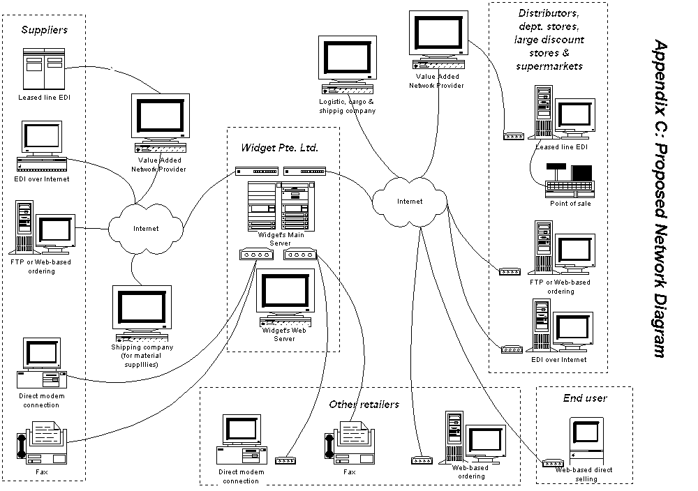
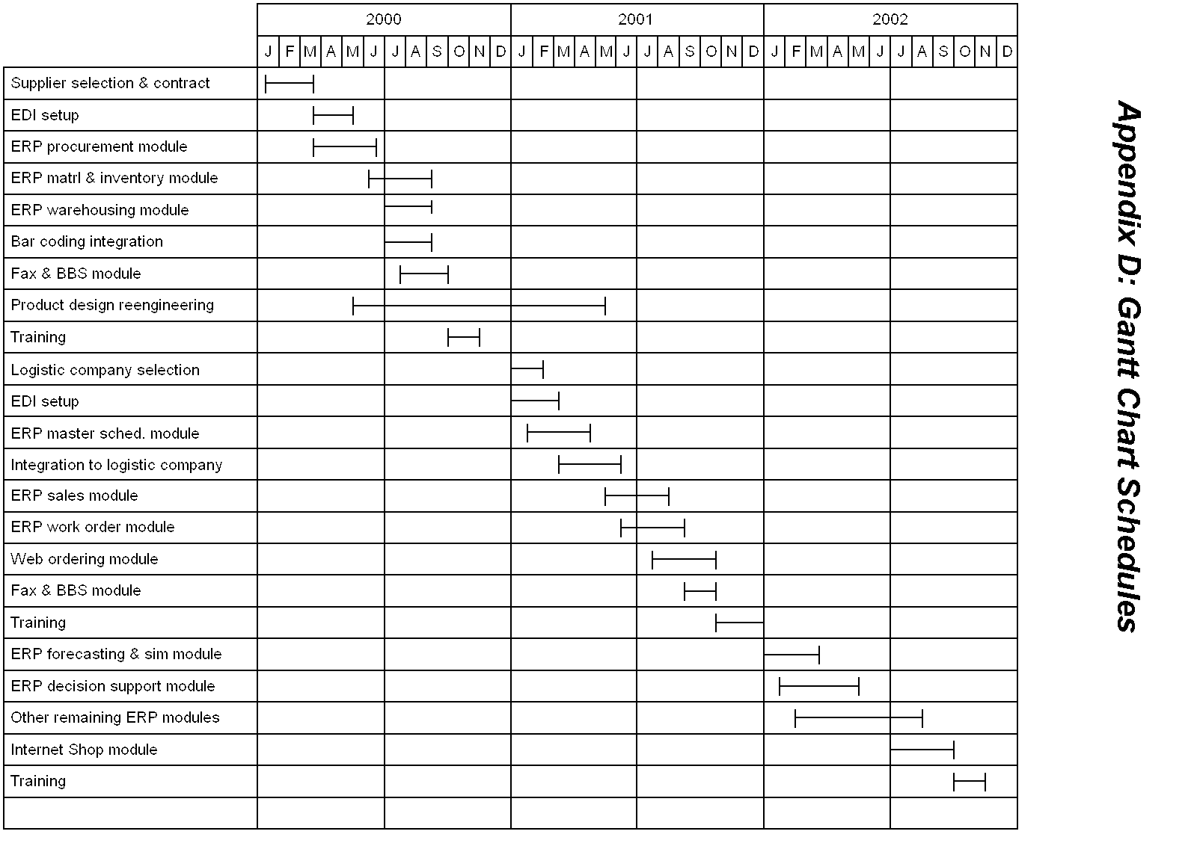

We need to distinguish customer (as defined earlier) with ‘end user’, as the later is the consumer which actually uses Widget’s kitchen appliances.

