Tugas 7

Perancangan Transistor MOSFET

Spesifikasi :
- transkonduktansi minimum 50 S
- tegangan breakdown 30 V

Dari buku Semiconductor Device (S.M. Sze) fig. 41 page 211
S
G
D
n⁺
SiO₂
d
Z

Kita asumsikan N_{A} = doping substrat = 4.10¹⁶ cm⁻³, maka untuk d = 250  = 250.10⁻⁸ cm diperoleh V_{T} = 0,45 V.
Dengan asumsi sambungan n⁺-p abrupt junction maka N_{D} = 100.N_{A} = 4.10¹⁸ cm⁻³.
$V_{\text{BR}}=\frac{ε_{\text{Si}}⋅ε_{c}^{2}}{2{\text{qN}}_{A}}$ dan $ε_{c}=\sqrt{\frac{2V_{\text{BR}}{\text{qN}}_{A}}{ε_{\text{Si}}}}$ dengan :
q = 1,6.10⁻¹⁹ C
N_{A} = 4.10¹⁶ cm⁻³
V_{BR} = 30 V
_{Si} = 11,9 . 8,854.10⁻¹⁴
maka : _{c} = 6,04.10⁵ Vcm⁻¹
$$W_{p}=\frac{ε_{\text{Si}}⋅ε_{c}}{q⋅N_{A}}=\frac{\text{11},9\text{.}8,\text{854}\text{.}{\text{10}}^{−\text{14}}\text{.}6,\text{04}\text{.}{\text{10}}^{5}}{1,6\text{.}{\text{10}}^{−\text{19}}\text{.}4\text{.}{\text{10}}^{6}}=1,\text{28}\text{.}{\text{10}}^{−4}\text{cm}$$
$$W_{p}=W_{0}=\frac{N_{A}\text{.}w_{p}}{N_{D}}=\frac{1}{\text{100}}\text{.}1,\text{28}\text{.}{\text{10}}^{−4}=1,\text{28}\text{.}{\text{10}}^{−6}\text{cm}$$
$$C_{0}=\frac{ε_{\text{ov}}}{d}=\frac{3,9\text{.}8,\text{854}\text{.}{\text{10}}^{−\text{14}}}{\text{250}\text{.}{\text{10}}^{−8}}=1,\text{38}\text{.}{\text{10}}^{−7}F/{{\text{cm}}^{2}}$$
$C_{0}=\frac{z}{L}\text{.}μ_{r}\text{.}C_{0}\text{.}N_{D}=\frac{z}{L}\text{.}μ_{r}\text{.}C_{0}\text{.}V_{\text{BR}}$ ; untuk Si maka _{r} = 1450
$$\frac{z}{L}=g_{m}\frac{1}{μ_{r}\text{.}C_{0}\text{.}V_{\text{BR}}}$$
Dari spesifikasi : g_{m} = 50
$$\frac{z}{L}=g_{m}\frac{1}{μ_{r}\text{.}C_{0}\text{.}V_{\text{BR}}}=\frac{\text{50}}{\text{1450}\text{.}1,\text{387}\text{.}{\text{10}}^{−7}\text{.}\text{30}}=8,\text{329}{μm}^{2}$$
Dengan mengambil L = 1.10⁻⁴ cm maka Z = 0,8329 cm = 8,329 m².
Jadi kontak untuk gate adalah A_{G} = Z.L = 8329 m².
Dengan asumsi L_{SD} = 10m, maka luas kontak alumunium untuk source dan gate adalah :
A_{S} = A₀ = Z . L_{SD} =83,29.10³ m².

Bandwidth dari MOS :
$$f_{T}=\frac{g_{m}}{2{πC}_{\text{in}}}=\frac{μ_{r}\text{.}V_{D}}{2{πL}^{2}}=\frac{μ_{r}\text{.}V_{\text{BR}}}{2{πL}^{2}}=7\text{.}{\text{10}}^{\text{11}}\text{Hz}$$

Hasil Rancangan :
Doping yang digunakan :
- substrat : N_{A} = 4.10⁶ cm⁻³
- n⁺ : N_{D} = 4.10¹⁸ cm⁻³

Kedalaman material :
- tipe n : W_{fb} = 1,28.10⁻⁶ cm
- tipe p : W_{G} = 1,28.10⁻⁴ cm
Luas kontak Al :
- Gate : A_{G} = 8329 m²
- Source : A_{S} = 83,29.10³ m²
- Drain : A_{D} = 83,29.10³ m²

Karakteristik I-V dan frekuensi tinggi :
Kurva I_{D}-V_{DS} :
- Daerah linear :
$$I_{D}=\frac{1}{2}μ_{n}C_{\text{OX}}\left[\frac{Z}{L}\right]\left(2\left(V_{\text{GS}}−V_{T}\right)V_{\text{DS}}−V_{\text{DS}}^{2}\right)$$
V_{DS} < V_{DS sat} dimana
$V_{\text{DSsat}}=V_{\text{GS}}−2ψ_{B}+k^{2}\left[1−\sqrt{1+\frac{2V_{\text{GS}}}{k^{2}}}\right]$ dan $\begin{aligned}k=\frac{1}{C_{0}}\sqrt{ε_{0}\text{.}q\text{.}N_{A}}=\frac{1}{1,\text{38}\text{.}{\text{10}}^{−7}}\sqrt{1,9\text{.}8,\text{854}\text{.}{\text{10}}^{−\text{14}}\text{.}1,6\text{.}{\text{10}}^{−\text{19}}\text{.}4\text{.}{\text{10}}^{−\text{16}}}=0,6 \\ Ψ_{B}=\frac{\text{kT}}{q}\text{ln}\left[\frac{N_{A}}{N_{i}}\right]=0,\text{0259}\text{ln}\left[\frac{4\text{.}{\text{10}}^{\text{16}}}{1,5\text{.}{\text{10}}^{6}}\right]=0,\text{383}V\end{aligned}$
Maka :
$$\begin{aligned}I_{D}=\frac{1}{2}\text{.}\text{1450}\text{.}1,\text{38}\text{.}{\text{10}}^{−7}\text{.}\text{8239}\text{.}2\left(2\left(V_{\text{GS}}−0,\text{45}\right)V_{\text{DS}}−V_{\text{DS}}^{2}\right) \\ I_{D}=0,\text{833}\left[2\left(V_{\text{GS}}−0,\text{45}\right)V_{\text{DS}}−V_{\text{DS}}^{2}\right]=1,\text{67}V_{\text{GS}}\text{.}V_{\text{DS}}−0,\text{75}\text{.}V_{\text{DS}−}0,\text{833}V_{\text{DS}}^{2}\end{aligned}$$
$$V_{\text{DSsat}}=V_{\text{GS}}−2\text{.}0,\text{383}+{0,6}^{2}\left[1−\sqrt{1+\frac{2V_{\text{GS}}}{{0,6}^{2}}}\right]=V_{\text{GS}}−0,\text{766}+0,\text{36}−0,\text{36}\sqrt{1+5,5V_{\text{GS}}}$$
$$V_{\text{Dsat}}=2,\text{67}V|_{V_{\text{GS}}=5V}$$
$$V_{\text{Dsat}}=5,\text{17}V|_{V_{\text{GS}}=8V}$$
- Daerah Saturasi :
$$\begin{aligned}I_{\text{Dsat}}=\frac{μ_{n}\text{.}Z\text{.}C_{\text{OX}}}{2d\text{.}L}{\left[V_{G}−V_{T}\right]}^{2} \\ I_{\text{Dsat}}=\frac{\text{1450}}{2}\left(\text{8329},2\right)\frac{3,9\text{.}{\text{10}}^{−\text{14}}\text{.}8,\text{854}}{\text{250}\text{.}{\text{10}}^{−8}}{\left[V_{G}−0,\text{45}\right]}^{2}=0,8{\left(V_{\text{GS}}−0,\text{45}\right)}^{2}\end{aligned}$$

Grafik I_{D}-V_{DS} :

Kurva karakteristik frekuensi tinggi :
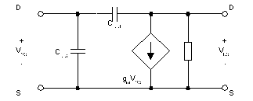
Dengan menggunakan rangkaian pengganti small signal untuk frekuensi tinggi :

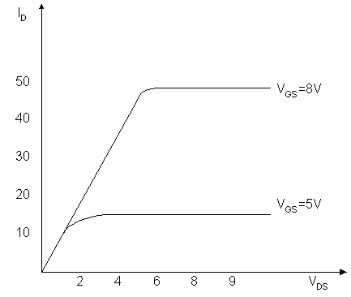

$$\begin{aligned}I_{\text{IN}}=jω\left(C_{\text{GS}}+C_{\text{GD}}\right)V_{\text{GS}}=ω\text{.}C_{0}\text{.}Z_{L}\text{.}V_{\text{GS}} \\ I_{\text{OUT}}=g_{m}\text{.}V_{\text{GS}} \\ \left|\text{Gain}\right|=\left|\frac{I_{\text{OUT}}}{I_{\text{IN}}}\right|=\frac{g_{m}\text{.}V_{\text{GS}}}{ω\text{.}C_{0}\text{.}Z_{L}\text{.}V_{\text{GS}}}=\frac{g_{m}}{ω\text{.}C_{0}\text{.}Z_{L}} \\ \text{Gain}=\frac{\text{50}}{2π\text{.}f\text{.}1,\text{38}\text{.}{\text{10}}^{−7}\text{.}8,\text{329}\text{.}{\text{10}}^{−8}}=\frac{6,\text{92}\text{.}{\text{10}}^{\text{11}}}{f}\end{aligned}$$

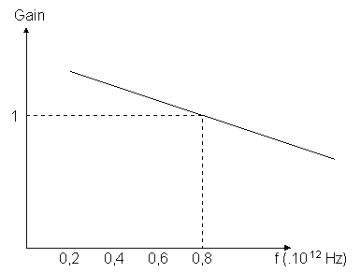
Karakteristik frekuensi tinggi :

