TUGAS 8

Karakteristik I-V dan Frekuensi Tinggi MOSFET

Pertama kali kita masukkan doping profile yang kita miliki ke dalam file mosfet.gr0. Dalam file ini nilai-nilai parameternya didapatkan dari tahap desain sebelumnya

Title File : mosfet.gr0
$ Tugas EL-312 (Devais Mikroelektronika)
$ Grid of the structure and doping distribution
$ Define rectangular grid
mesh rectangular nx=25 ny=25 diag.flip smooth=1
x.mesh n=1 l=0 r=1
x.mesh n=25 l=2.5 r=1
y.mesh n=1 l=-0.1 r=1
y.mesh n=3 l=0 r=1
y.mesh n=14 l=0.7 r=1.05
y.mesh n=25 l=2.5 r=1.2
$ Regions
region num=1 y.max=0 oxide
region num=2 y.min=0 silicon
$ Electrodes
$ #1-GATE #2-SUBSTRATE #3-SOURCE #4-DRAIN
electrode num=1 x.min=0.520 length=1.460
electrode num=2 substrate
electrode num=3 source length=0.417 y.min=0 y.max=0
electrode num=4 drain length=0.417 y.min=0 y.max=0
$ Doping and Fixed Charge
doping reg=2 gauss conc=9.7947e15 characteristic=0.10
+ acceptor peak=0.0 outf=doping.mos
doping reg=2 gauss conc=1.e20 characteristic=0.10
+ donor peak=0.0 x.r=0.6 ratio=0.75
doping reg=2 gauss conc=1.e20 characteristic=0.10
+ donor peak=0.0 x.l=2.0 ratio=0.75
doping reg=2 uniform conc=9.7947e15 acceptor
$ Regrid on Doping
plot.2d grid no.top boundary no.fill pa
regrid doping log reg=2 ratio=4 smooth.k=1 outf=mesh1.mos dopfile=doping.mos
regrid doping log reg=2 ratio=4 smooth.k=1 outf=mesh2.mos dopfile=doping.mos
$ Contact
contact num=1 n.polysilicon
symbolic gummel carriers=0
solve initial
regrid potential ratio=0.2 region=2 smooth.k=1 outf=mesh3.mos dopfile=doping.mos
$ Plotting
plot.2d grid no.top boundary no.fill pa
plot.1d log abs doping x.s=0 y.s=0 x.e=0 y.e=2.5 points pa
plot.1d log abs doping x.s=0 y.s=0 x.e=2.5 y.e=0 line.type=2 pa
plot.1d log abs doping x.s=1.2 y.s=0 x.e=1.2 y.e=1.5 line.type=2 pa
end

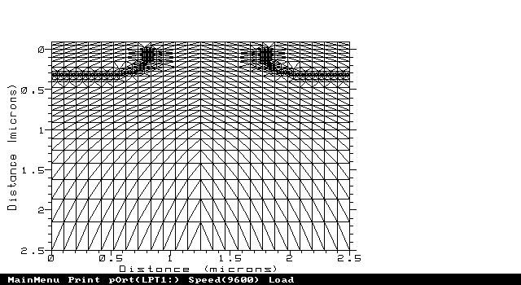
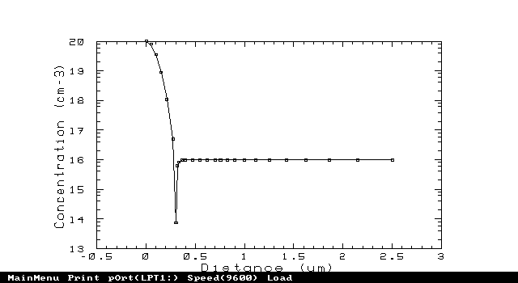
Output plot:

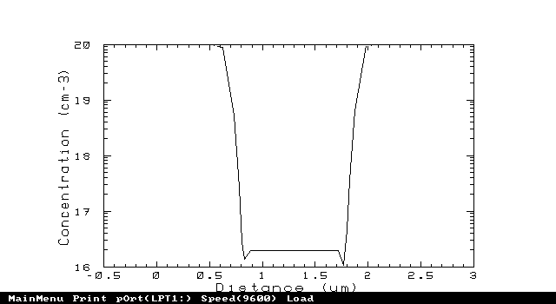
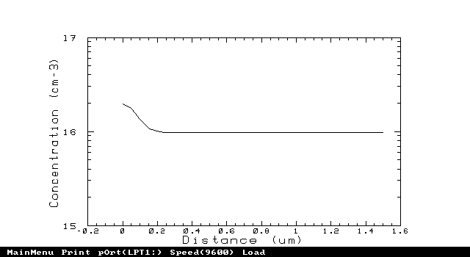

Title File : mosfet.gr1
$ Tugas EL-312 (Devais Mikroelektronika)
$ Full set of Id / Vd for gate voltages = 1, 2, 3 and 4 V
mesh inf=mesh3.mos
contact num=1 n.polysilicon
models print temp=300 conmob fldmob bgn fermi incomplete
+ tfldmb2 OX.L=0.6 OX.R=2.
interf qf=3e10
symb newton carrier=1 electrons
method xnorm autonr itlimit=30 trap atrap=.5 p.tol=1.e-4 c.tol=1.e-4
solve initial
solve previous v4=0.005
solve project vstep=0.25 nstep=3 elect=1
solve project v1=1.0 outf=g111.mos
solve project vstep=0.25 nstep=3 elect=1
solve project v1=2.0 outf=g211.mos
solve project vstep=0.25 nstep=3 elect=1
solve project v1=3.0 outf=g311.mos
solve project vstep=0.25 nstep=3 elect=1
solve project v1=4.0 outf=g411.mos
$ Calculate drain characteristics for each gate voltage
load inf=g111.mos
log outf=d111.mos
solve vstep=0.1 nstep=9 elect=4 previous
solve previous v4=1.0 vstep=0.1 nstep=40 elect=4
load inf=g211.mos
log outf=d211.mos
solve vstep=0.1 nstep=9 elect=4 previous
solve previous v4=1.0 vstep=0.1 nstep=40 elect=4
load inf=g311.mos
log outf=d311.mos
solve vstep=0.1 nstep=9 elect=4 previous
solve previous v4=1.0 vstep=0.1 nstep=40 elect=4
load inf=g411.mos
log outf=d411.mos
solve vstep=0.1 nstep=9 elect=4 previous
solve previous v4=1.0 vstep=0.1 nstep=40 elect=4
end

Title File : mosfet.gr2
$ Tugas EL-312 (Devais Mikroelektronika)
$ Substrate current vs gate voltage for drain voltages of 4.0 and 5.0V
mesh inf=mesh3.mos
contact num=1 n.polysilicon
models print temp=300 conmob fldmob bgn fermi incomplete
+ tfldmb2 OX.L=0.6 OX.R=2.
impact
interf qf=3e10
$ Calculate initial solution
symb carriers=0
method iccg damped itlimit=30
solve init
$ Calculate solution at gate voltage Vg=0.3 V and two drain voltages
solve v1=0.3 v4=4.0 local outf=sb4.mos
solve v1=0.3 v4=5.0 local outf=sb5.mos
symb newton carrier=2
method xnorm autonr itlimit=16 trap atrap=.5 p.tol=1.e-3 c.tol=1.e-2
$ Calculate substrate current versus gate voltage at Vd = 4.0 V
load inf=sb4.mos
log outf=substr4.mos
solve prev v1=0.4 vstep=0.1 nstep=6 electr=1
solve prev vstep=0.5 nstep=6 electr=1
$ Calculate substrate current versus gate voltage at Vd = 5.0 V
load inf=sb5.mos
log outf=substr5.mos
solve prev v1=0.4 vstep=0.1 nstep=6 electr=1
solve prev vstep=0.5 nstep=6 electr=1
end

Title File : mosfet.gr3
$ Tugas EL-312 (Devais Mikroelektronika)
$ AC simulation
mesh inf=mesh3.mos
contact num=1 aluminum
interf qf=3.e10
symb newton carr=2
method xnorm autonr
models print temp=300 fldmob srh auger conmob tfldmb2 ox.l=0.0 ox.r=2.0
solve init
log acfile=ac.mos
solve previous v1=-1.00 ac freq=1.e6 term=12
solve previous v1=-0.75 vstep=0.5 nstep=25 elect=1 ac freq=1.e6 term=12
end

Title File : mosfet.gr4
$ Tugas EL-312 (Devais Mikroelektronika)
$ AC simulation
mesh inf=mesh3.mos
contact num=1 aluminum
models print temp=300 conmob fldmob bgn fermi incomplete
+ tfldmb2 ox.l=0.6 ox.r=2 ox.b=0
interf qf=3.e10
symb newton carr=2
method xnorm autonr itlimit=20 trap atrap=.5 p.tol=1.e-4 c.tol=1.e-4
load inf=g411.mos
symb newton carr=2
log acfile=ac1.mos
solve ac freq=1 fstep=4 mult.f nfstep=15 vss=0.01
+ max.inner=250 s.omega=0.30 terminal=2
end

Title File : mosfet.iv1
$ Tugas EL-312 (Devais Mikroelektronika)
$ Plot substrate current vs gate voltage
mesh inf=mesh3.mos
plot.1d inf=substr5.mos x.ax=v1 y.ax=i2 abs
+ x.label=Vgate y.label=Isub min.value=-13 x.max=6 log points pa
+ title="Isubstrate vs Vgate"
plot.1d inf=substr4.mos x.ax=v1 y.ax=i2 abs log points unch pa
end
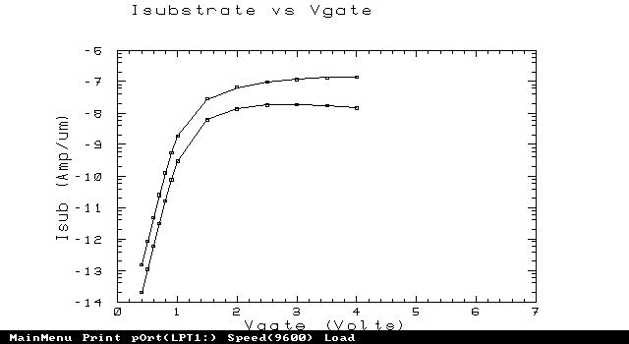
Output plot:

Title File : mosfet.oc1
$ Tugas EL-312 (Devais Mikroelektronika)
$ Plot karakteristik output
mesh inf=mesh3.mos
plot.1d inf=d411.mos x.ax=v4 y.ax=i4 abs x.label=Vds y.label=Ids pa
+ title="Fitting N-MOSFET" max=3.9e-4
+ subtitle="Karakteristik output"
plot.1d inf=d311.mos x.ax=v4 y.ax=i4 abs unch pa
plot.1d inf=d211.mos x.ax=v4 y.ax=i4 abs unch pa
plot.1d inf=d111.mos x.ax=v4 y.ax=i4 abs unch pa
fit mos fit.type=2 bulk=2 drain=4 gate=1 line1.type=4 line2.type=5
end
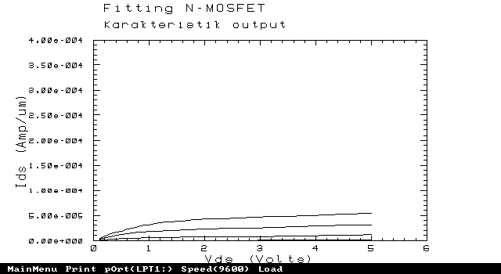
Output plot:

Title File : mosfet.cv1
$ Tugas EL-312 (Devais Mikroelektronika)
$ AC Simulation
mesh inf=mesh3.mos
plot.1d inf=ac.mos x.ax=v1 y.ax=c12 points
+ title="Plot kapasitansi vs Vgate"
+ y.label="Cgate-substrate" x.label="Vgate" pa
end
Output plot:
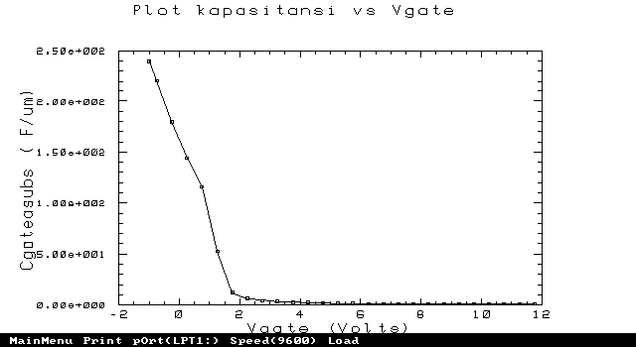
Title File : mosfet.gf1
$ Tugas EL-312 (Devais Mikroelektronika)
$ Plot gain terhadap frekuensi
mesh inf=mesh3.mos
plot.1d inf=ac1.mos x.ax=freq y.ax=i4/v1 abs
+ title="Kurva karakteristik" subtitle="frekuensi tinggi"
+ y.label="Penguatan" x.label="Frekuensi" pa
end
Output plot:
