Bandung, 7 Mei 2005

KIT FM Transmitter 87.5 -108 Mhz

PLL FM PFD152
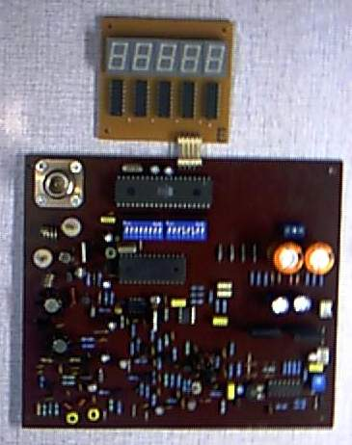

PLL FM mono < MC145152 >, Displays 5 digit , range freq 82. – 118 Mhz, step channel 10 Kc, broadband VCO, power output 500 - 1500 mW, CT 18VAC / 1.5 Amp

Price : Rp. 750.000. –

PLL FM P1022
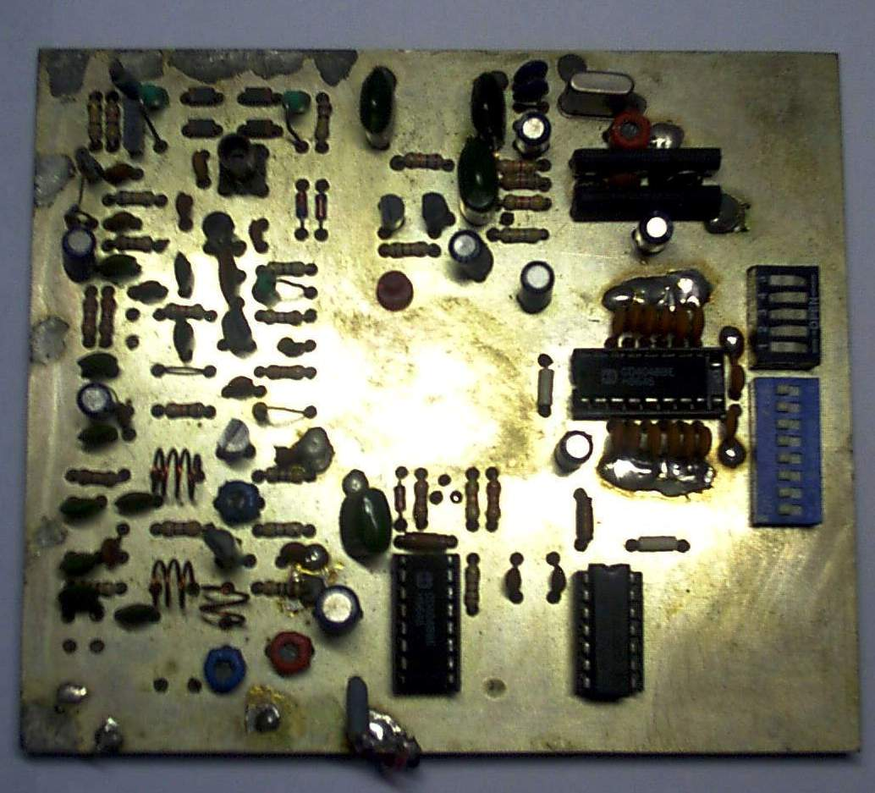

PLL FM mono < TC 9122 >, range freq 87.5 – 108 Mhz, step channel 100 Kc, broadband VCO, power output 500 mW, 12 VDC / 0.5 Amp

Price : Rp. 500.000. –

PLL FM P1093
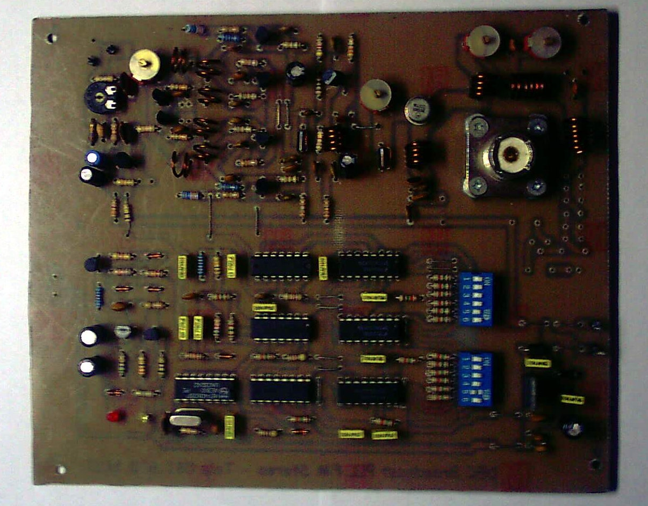
PLL FM mono < 74LS193 >, range freq 87.5 – 108 Mhz, step channel 100 Kc, tune VCO, power output 500 mW, 12 - 16 VDC / 0.8 Amp

Price : Rp. 300.000. –
PLL FM P593
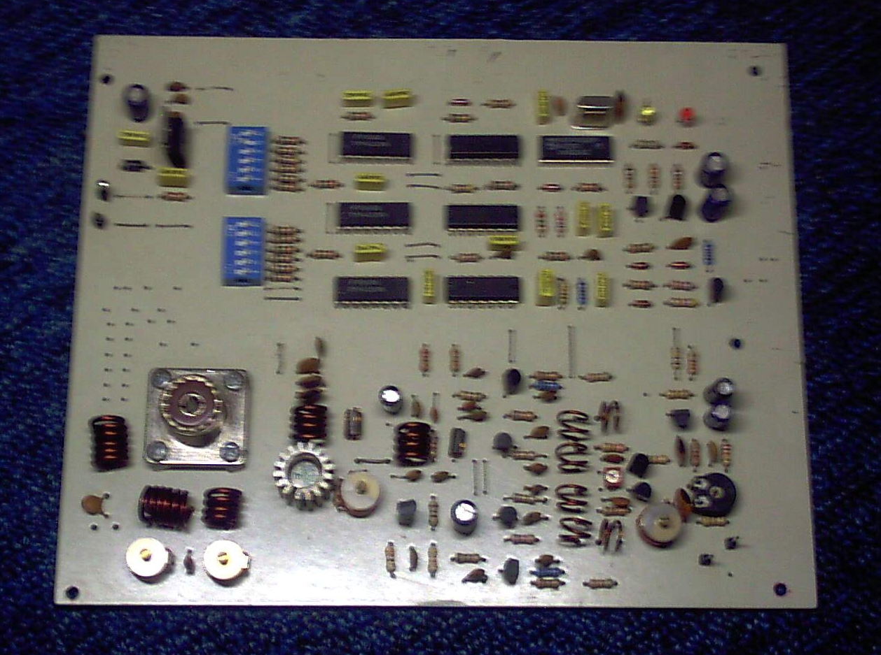
PLL FM mono < 74LS193 >, range freq 87.5 – 108 Mhz, step channel 50 Kc, tune VCO, power output 500 mW, 12 - 16 VDC / 0.8 Amp

Price : Rp. 350.000. –

PLL FM P551
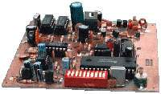
PLL FM mono < MC145151 >, range freq 87.5 – 108 Mhz, step channel 10 Kc, broadband VCO, power output 500 - 1000 mW, 12 – 18 CT VAC / 1.5 Amp

Price : Rp. 650.000. –

PLL FM P152
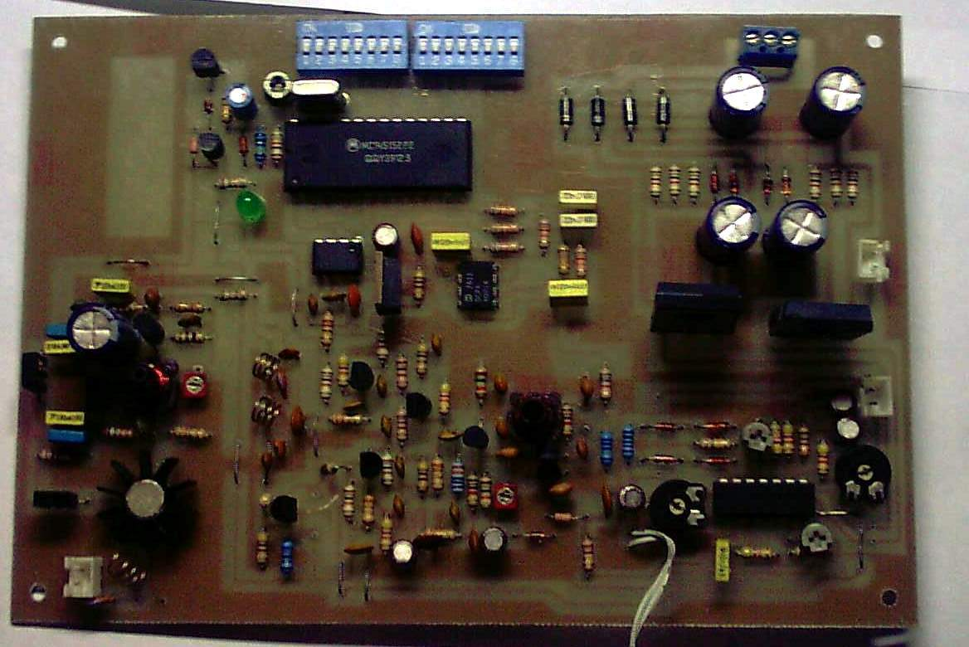

PLL FM mono < MC145152 >, range freq 87.5 – 108 Mhz, step channel 10 Kc, broadband VCO, power output 500 - 1000 mW, 12 – 18 CT VAC / 1.5 Amp

Price : Rp. 650.000. –

Display Freqwency
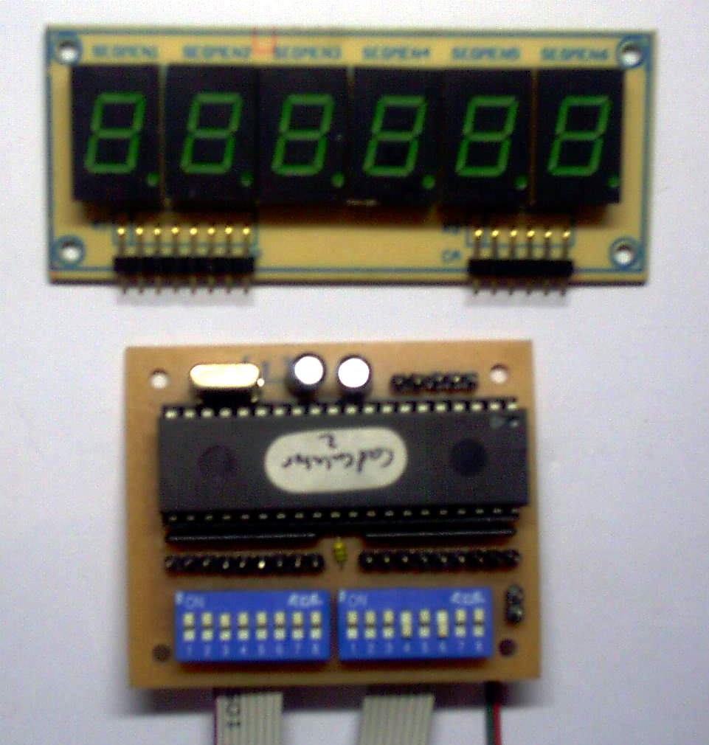
Controller freqwency displays < seven segment > to PLL Veronica, Ramsey, MC145151 and MC145152 < biner calculated >

Price : Rp. 300.000. –

Stereo Generator Pro
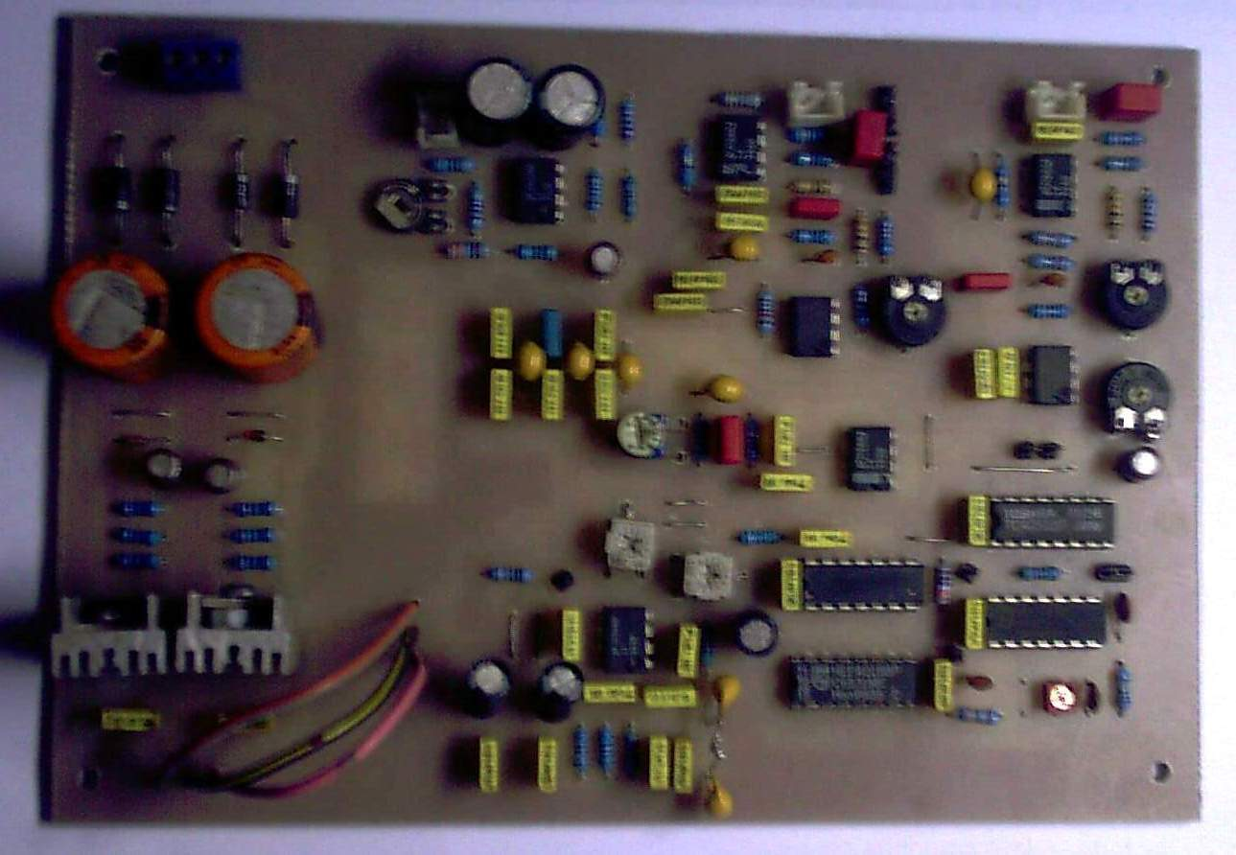

Stereo generator mengunakan system Matrix

Price : Rp. 450.000. –

Stereo Generator CX
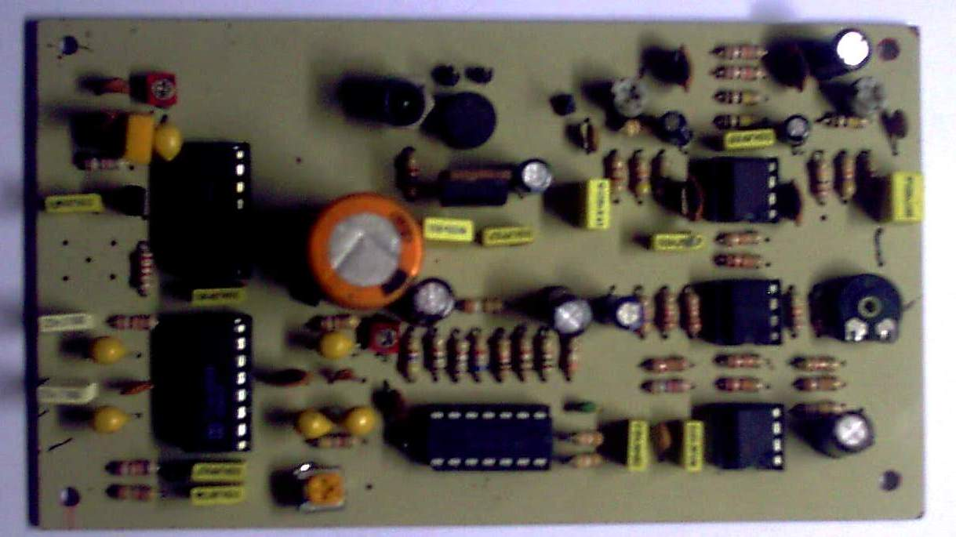

Stereo generator mengunakan system balans modulator MC1496

Price : Rp. 300.000. –
Booster 30 Watt – BFM30W
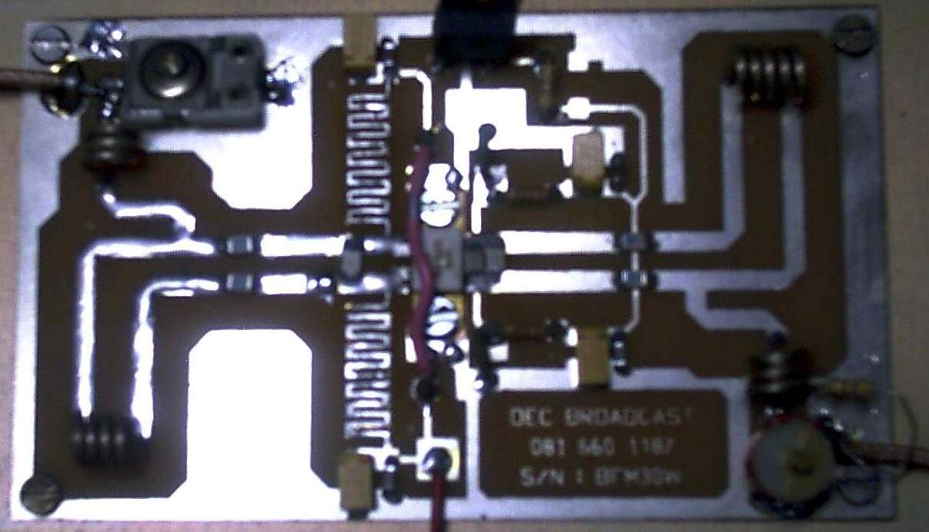

Broadband 87.5 – 108 Mhz output 30 watt, input 500 s/d 1watt
Price : Rp. 200.000. –

Booster 30 Watt – 60W
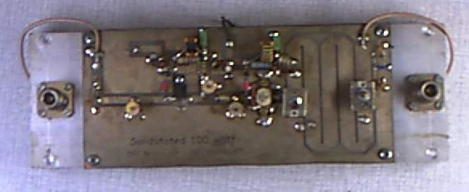

Tidak Broadband 87.5 – 108 Mhz output 60 watt, input 200mW s/d 1watt
Price : Rp. 500.000. –

Booster 100 Watt – 100W
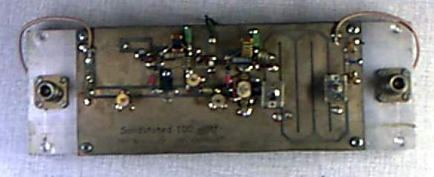

Tidak Broadband 87.5 – 108 Mhz output 100 watt, input 250mW s/d 1watt
Price : Rp. 900.000. –

Booster 100 Watt – BFM100W
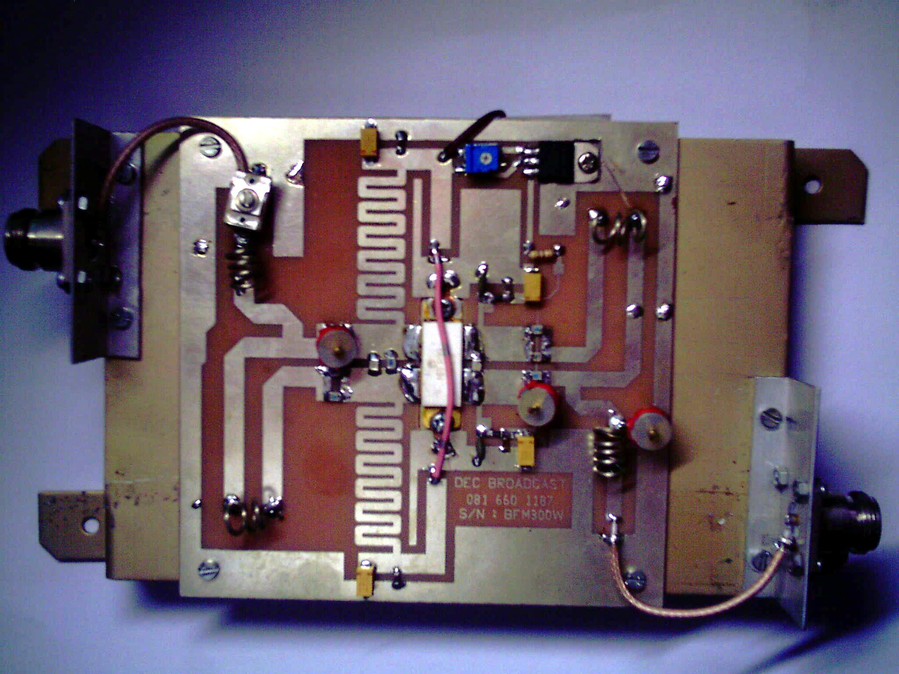

Broadband 87.5 – 108 Mhz output 100 watt, input 18 s/d 20watt

Price : Rp. 1.500.000. –

Booster 200 Watt – BFM200W
Broadband 87.5 – 108 Mhz output 200 watt, input 30watt
Price : Rp. 1.850.000. –

Booster 300 Watt – BFM300W
Broadband 87.5 – 108 Mhz output 300 watt, input 60watt
Price : Rp. 2.250.000. –

Booster 200 Watt – EL160W
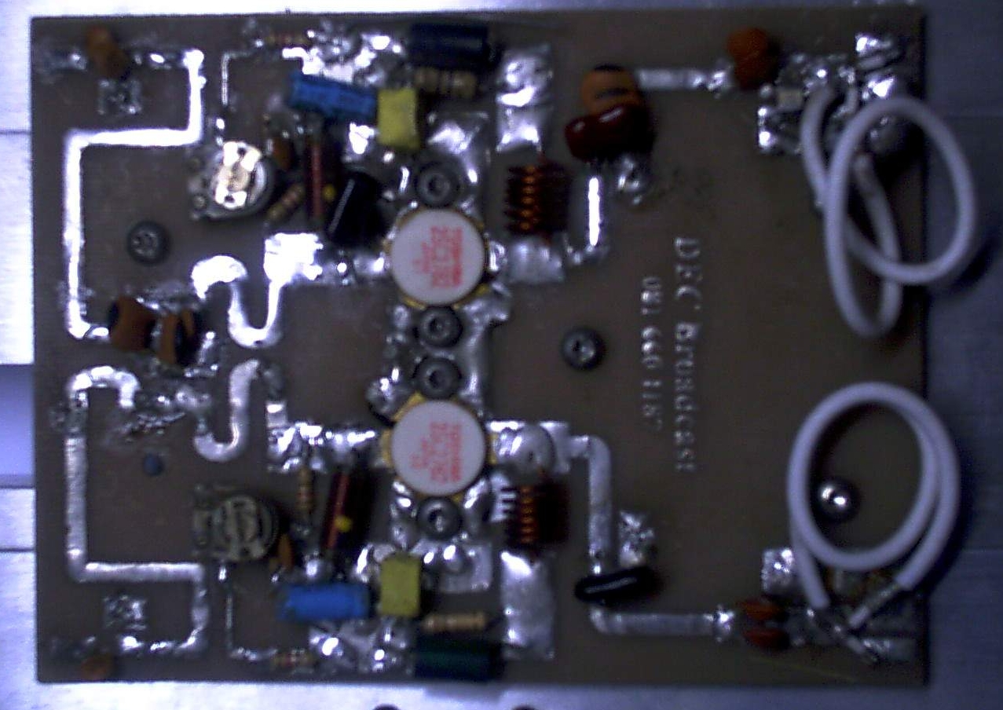
Broadband 87.5 – 108 Mhz output 200 watt, input 60watt
Price : Rp. 950.000. –

Untuk keterangan kelengkapan , pemesanan jenis paket atau satuan berupa booster saja silahkan menghubungi 022 – 7205282 atau 081 660 1187.
Sebelumnya kami ucapkan banyak terimakasih atas perhatianya.

Harga sewaktu – waktu dapat berubah tanpa pemberitahuan lebih dahulu.

( T.D.A Beben )

