Claroline 1.3 Teacher Manual

Introduction
Claroline is a Web Based Course Management System. It allows teachers (professors, lecturers...) to create and admin course websites through a browser (Explorer, Netscape...). You can
- Publish documents in any format (Word, PDF, HTML, Video...)
- Admin public or private discussion forums
- Manage a list of links
- Create student groups
- Compose exercises
- Structure an agenda with tasks and deadlines
- Make announcements (also via email)
- Have students submit papers
Technically speaking, you need only to be familiar with your preferred browser. You will be asked to type text in forms, to click on 'OK' buttons and to prepare locally on your own computer quality documents to be uploaded on your website. Nothing more.
Many teachers become familiar with Claroline in two or three hours without any dedicated technical training. Even reading this manual may proove superfluous. This way, you can concentrate on the most important for a teacher: content and a good educational scenario, but you remain autonomous and don't need a technical team to manage your course website.
The present Teacher Manual lists all functions of Claroline for the teacher and explains how they work. It may appear usefull to check Student Manual to see things from his/her point of view

Self registering and creating a course website
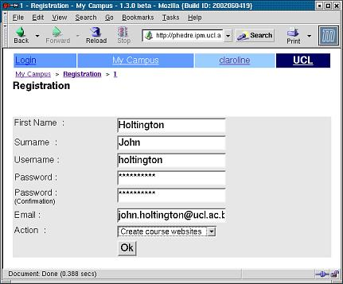
Depending on your institution security choices, you are allowed to self-register as a professor or you are not allowed and should recieve your registration settings from your institution administration. This manual only covers self-registration process.
- Open your browser (Explorer, Netscape...)
- Type your insititution's Claroline website address (http://something...)
- Select Registration
- Enter your personnal settings (password twice and valid email required)
- Select 'Create course websites' as Action.
- Validate (=click 'Ok')
- Enter a title for the course
- Select the category (or department) from the drop down menu
- Enter a course code (if you don't have one, invent one, something like BIODIV2342)
- Enter the names of the Lecturer(s) delivering the course in the 'Professor(s)' section
- N.B. do so as you wish to have them appear to the students
- Select the language that you wish the site to appear in
- Validate
- Follow the link that appears to return to the My courses area
- Click on your newly created course title
- You should now see your course website Home Page

Login / logout
Every time you go back to the internet campus of your institution, you will need to enter username and password.
Depending on your institution security choices, you have defined username and password yourself at self registration (and recieved an email to remind you) or you have been informed of username/password by your administration.
In both cases, this username / password pair is associated to User Rights on the system. It tells the system you are a member of the staff and are allowed to create new courses, admin and delete your own courses, create new users (can be disabled by your institution) and some other things.
At the end of your visit to your courses, you should go back to campus Home Page and Logout.

Administering a course
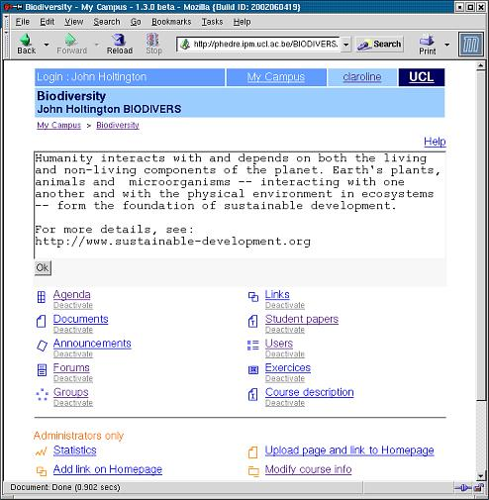
From the' My course's menu (i.e. after you are logged in the system and have already created a course website)
- Click on the title of the course that you wish to administer
The course main page contains all the features visible to the students, but there are more options available, and two additional sections to this screen.
If you see course from student point of view (i. e. you see course home page but are not offered to edit, modify, deactivate or delete its content), then the login you entered is not a valid teacher login. A solution to this may be to self-register once again and inform your system administrator that your ancient login can be deleted.
At the top of the screen is the introduction text for the course.
- Click on Modify to alter the text that is displayed
- Edit/Add text, then click 'Ok' to update the introduction text
- N.B. It is possible to add styles, e.g. <b>This is bold</b> or any HTML tags.
- Links beginning with 'http://' and email addresses containing the '@' will be automatically clickable.
- Click on 'Delete' to remove the introduction text for the course.
- N.B. No confirmation is requested – take care!

Agenda
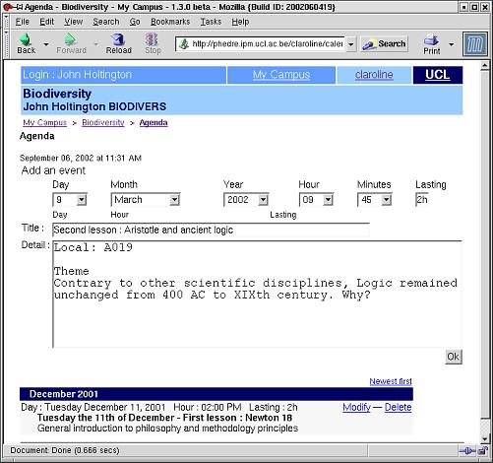

To add an agenda item
- Select the correct Day from the drop down menu
- Select the correct Month from the drop down menu
- Select the correct Year from the drop down menu
- Select the correct Hour from the drop down menu
- Select the correct Minute from the drop down menu
- Enter a duration for the agenda item (optional)
- Enter a title for the agenda item
- Enter details for the agenda item
- Click on Ok
The new item will appear in the list of agenda items

To modify an agenda item
- Click on the Modify link next to the agenda item to be changed
- Amend the details displayed as required
- Click on Ok to accept changes

To delete an agenda item
- Click on the Delete link next to the agenda item to be removed
- N.B. No confirmation is requested, so delete with care!!!

Documents
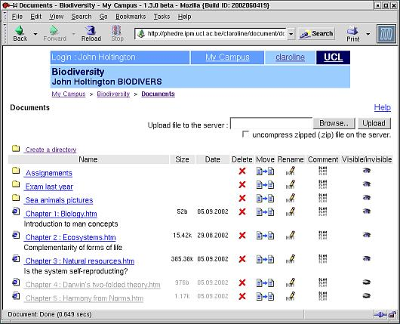
This section provides a comprehensive mechanism for organising files that you would like to make available to the students. It is possible to make many directories, and to have directories within directories to enable grouping of files.
It is possible to
- Delete
- Move
- Rename
- Add a comment
- Or stop students seeing files

To create a directory
- Click on the create directory link
- Enter the name of the directory into the highlighted box
- Click on Ok to create the directory

To upload files into a directory
- Click on the link next to the directory that you wish to upload into
- Click on the Browse button
- Navigate to the local file that you wish to upload
- Click on the Upload button
The upload procedure should complete, and you will be able to see the uploaded file.
N.B. There are two size restrictions. Files must be smaller than 10MB to be uploaded, and the total amount of files in this are is not allowed to exceed 30MB (your institution may have odified these default values). If you wish to increase this amount then contact your campus administrator.

To rename files
- Click on the pencil item in the Name column that is in the same row as the file that you wish to rename.
- Edit the name in the box that appears
- Click Ok to change the name

To add a comment
- Click on the comment icon in the Comment column that is in the same row as the file to which you wish to add a comment
- Add the comment to the box
- Click Ok to add the comment
To hide the file from users of the system
- Click on the open eye icon in the Visible/Invisible column that is in the same row as the file to hide
- The icon should change to a closed eye (Invisible)
To show a hidden file to users of the system
- Click on the closed eye icon in the Visible/Invisible column that is in the same row as the file to hide
- The icon should change to an open eye (Visible)
To move a file
- Click on the move icon in the Move column that is in the same row as the file that you wish to move
- In the dropdown menu that appears select the directory where you wish the selected file to be moved to

To delete a file from the server
- Click on the red X icon in the Delete column that is in the same row as the file that you wish to delete.
- N.B. Currently no confirmation is requested, so delete with care
- Future upgrades will request confirmation before the file is deleted.

Announcements
To add an announcement
- Enter text into the box
- Check ' Send this announcement by email to registered students' box if needed
- Click on 'Ok'

To Modify an existing announcement
- Click on Modify immediately below the announcement you wish to change
- Correct the announcement text
- Click on 'Ok'

To Delete an existing announcement
- Click on 'Delete' immediately below the announcement you wish to delete.
- N.B. No confirmation is required – take care!

Forums
Click on the 'Forums' option
To post messages, use forums as a student would use them (See Student Manual)
To admin forums (create, delete forums, modify their name...), click on 'Administer'
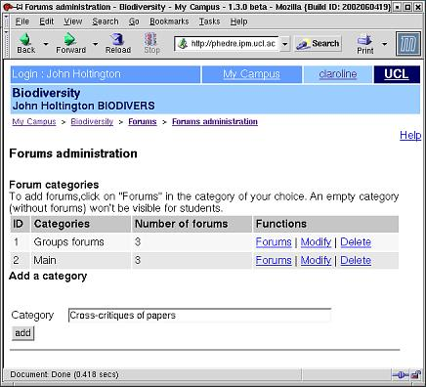

To add a category
- Enter a name for the category into the box
- Click on the Add button
- Your category WILL NOT APPEAR TO STUDENTS UNTIL YOU ADD FORUMS IN IT!

To delete a category
- Click on the Delete link
- N.B. No confirmation required – take care

To modify a category
- Click on Modify
- Change the name of the category
- Click on Ok

To Add/Edit/Delete individual forums within a category
- Click on Forums
The options work in exactly the same manner as those just described

Links

To add a link
- Enter the URL for the link, e.g. http://www.google.com/
- Enter the name for the link (will be used to make the link)
- Enter a description of the material at the linked destination
- Click on Ok

To delete the whole list
- Check the Delete the whole list box
- Click on Ok
- N.B. No confirmation is required – use with care!!!

Student Papers
There’s not too much that can be modified here, other than the instructions to be given to the students.
This area is likely to be modified in future upgrades, but at present it allows students to upload documents that everyone can see, future releases will offer the option to only allow the sender and the admin to see them, i.e. it could be used for work submission (assignments).

To modify the instructions to the students
- Click on Modify
- Change the text in the box
- Click on the Ok button immediately below the text box that you’ve just altered.

To delete the instructions
- Click on Delete
- N.B. No confirmation is requested – take care with this option!

Users
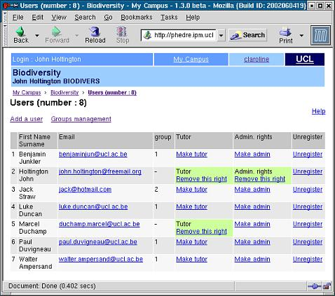
This is the section where you can control who is registered on your course
You can add students (but it is easyer for everybody to have them self-register otherwise you will need to inform them one by one of their username/password and there is a risk of double registration of the same person)

To add a student
- Click Add student
- Fill personnal data with correct email so that he/she recieves username/password
- Validate
To delete a student, clisk on 'Unregister'. The student will remain in your campus main database, but he/she ill not be associated with your course anymore.
You cannot modify student settings like name or password because it is up to them to know who they are and correct their own profile.
To insert Tutors in your course, the simplest is to ask your tutors to register as simple students and then click on Make Tutor beside their name. You can also register your tutors through 'Add a user', but it is risky as you don't know whether they are already registered on the system for other courses.
Being a tutor does not give admin rights on the website but allows to be member of more than one group (where student can be member of only one group at a time). This will proove usefull once you compose your groups, especially when you use Manual Editing of groups to associate tutors to groups.
You can give Admin Rights to any user of your course, whether stuent or tutor. But TAKE CARE! as this gives him/her the same rights on the website as yours: to add, modify and delete all content, and even the website itself!
Users tool is tightly connected to Groups tool for obvious reasons (groups are users groups). However, you will be allowed to create empty groups if your students are not registered yet. This way, you can organise the structure of your course before beginning of it. See Groups.

Groups
You can create groups of students. A group is a collection of students sharing the same forum and/or the same documents upload area. To create groups:
- Select Create New Group(s)
- Enter values (maximum is not necessary and can be empty, but then you will not be able to fill groups randomly as everybody will be registered in the first group whose size is unlimited)
- Cick on Create to validate
- Then select Modify settings to determine
- whether students can self-register in groups or if you prefer manual or random filling
- whether groups recieve a forum, a documents upload area or both
- whether forums are private (only fro group members) or public (any other student can read and write)
- Validate
If needed and if your users list is not empty, you can now fill groups automatically by random or edit every group one by one to enter users one by one. This manual editing can also be done after automatic filling or self-registering to fine tune group composition, check who is where and so on, move one specific student, etc.
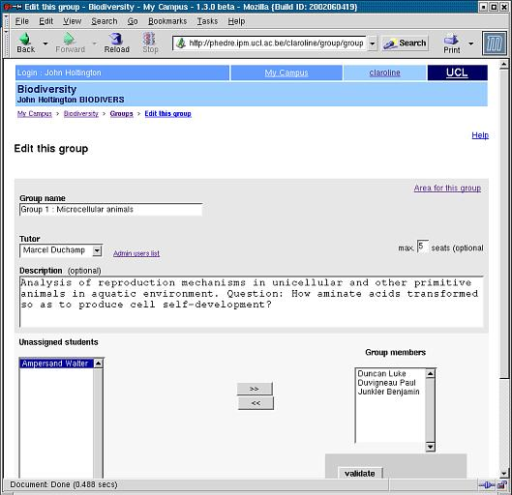

To edit a group manually:
- Click on the pencil icon beside the group name (groups must be created beforehand)
- Modify Name
- Click on the pencil icon beside the group name (groups must be created beforehand)
- Modify Name
- Attach a tutor (tutors must be allowed tutor right first through users list)
- Write a description (a task, a list of activities, a problem, anything...)
- Move students from right to left and/or left to right to modify group composition
- Validate
- Modify max seats (existing members will not be removed if there is more than new value you enter)
- Attach a tutor (tutors must be allowed tutor right first through users list)
- Write a description (a task, a list of activities, a problem, anything...)
- Move students from right to left and/or left to right to modify group composition
- Validate
As a lecturer, you are allowed to enter every forum and group document area. Tutors will enter any group too, but forums list will mention to them which groups they supervise.

Exercises
This is a quiz generator. Allowing the generation of multiple choice tests. These are formative however, as the system is not sufficiently secure to ensure the test responder is the account holder.
To create an Exercise
- Enter a name for the exercise in the box
- Click on Ok
- Enter a subtitle if necessary
- Enter the question that you wish to ask
- Enter a description
By default you are only given 2 possible answers (True/False)

If you wish to have more possible answers then
- Press +Answ for each additional answer you require

If you wish the reduce the amount of possible answers then
- Press –Answ for each answer to be removed
- Place a tick in the checkbox for the correct answer
- In the answer column Enter the text for the possible answers to the questions
- In the comment column Enter feedback that is given if a student selects that answer.
- Click on Save Exercise (if you’ve completed the exercise) OR Save Question
After saving the exercise you can adjust the scoring mechanism. The default values should be adequate, but you can modify them, then validate.
The principle of this scoring table is to define proper weight to number of good answers by question. For instance, if you have a question with 4 answers (possibly more than one right) and the student has two wrong and two right, you can give him half of the points, but you can also decide that this is not satisfactory and give, for instance, maximum points (20) if everything is right and zero points in any other combination.

Statistics
Only administrators/lecturers can see the statistics, clicking on this link allows you to see how much usage the course has had, together with other information, e.g. browsers used etc.

Add a page to site
A link to an uploaded HTML page can be made on the home page.
- Click on the browse button and navigate to the HTML file to be uploaded
- Enter text for the link to be created
- Click Ok
To remove that page, send a new version or change its name, there is presently no other solution than deactivating the page and beginning again the whole process. More in future versions.

Link to an External site
- Enter the URL to the page that you wish to link to in the link box
- Enter text for the link
- Click on Ok
To remove that link or edit it, there is presently no other solution than deactivating the link and beginning again the whole process. More in future versions.

Course Information
This option allows you to modify course details, together with deleting the whole course and controlling access to the course.
Alter the
- Course code
- Professor (Lecturers)
- Course title
- Faculty
- ...
as require
- Change the confidentiality of the course:
- Public acces = anybody can visit your website without even registering or logging in. And it is linked on your campus Home Page.
- Private access, registration open = people need to register and log in before entering your website, but anybody can register through your campus self- registration system
- Private access, registration closed = only people already registered have access to course website.
Tip: to have students self-register but eliminate possible intruders. Open self-registration during one week, invite your students to self-register, then close self-registration, go to users list and eliminate people who have not been invited.
- Select the language that you wish the pages to be displayed in (uploaded files will need to be translated).
- Click 'Ok'
- Follow the appropriate link

If you wish to delete the entire course
- Click on the Delete the whole course website link

If you really do want to delete the entire site
- Click YES

Otherwise
- Click NO
Take care as there are no second chances with this option.

Activate / Deactivate course components
Active course components appear in colour in the upper portion of the course home page with the link Deactivate below them
Deactivated components appear in grey in the lower portion of the course home page with the link Activate below them
- Activated components are seen by students
- Deactivated components are invisible to students
It is up to individual lecturing staff to decide which course components are required for each course.

To Deactivate a component
- Click on the Deactivate link below it’s name

To Activate a component
- Click on the Activate link above it’s name
Deactivated components are still functional and you can still use them. For instance you can upload documents through your documents tool even if it is deactivated. Deactivated only means invisible to students.

Queries
If there are any further requests, then contact:
- Your system administrator
- Claroline support forum: http://www.claroline.net/

